**1**  [**FNU | LIBRARY**](http://www.fnu.ac.fj/library/) **– (**Fiji National University, Fiji)

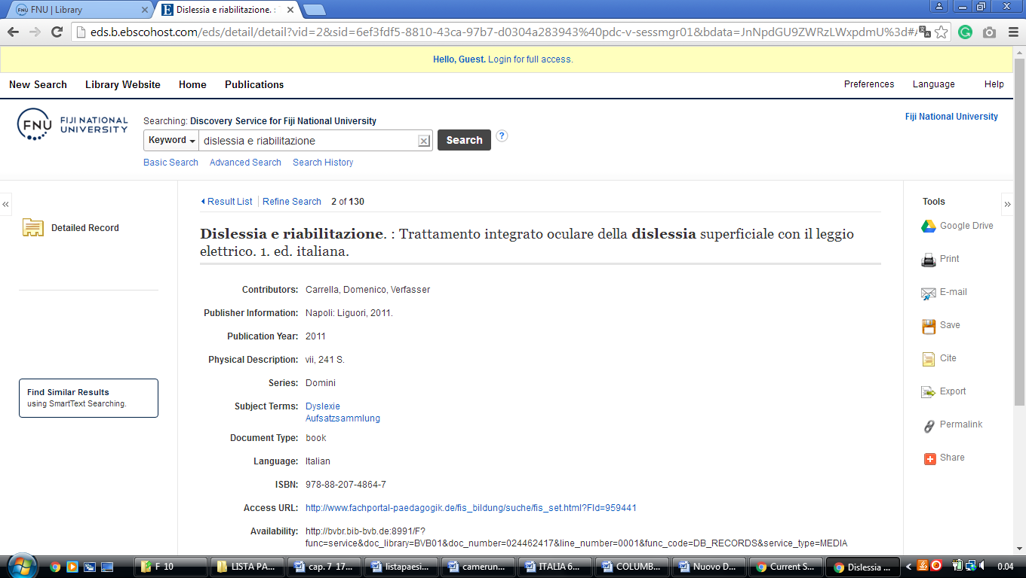<http://eds.b.ebscohost.com/eds/detail/detail?vid=2&sid=6ef3fdf5-8810-43ca-97b7-d0304a283943%40pdc-v-sessmgr01&bdata=JnNpdGU9ZWRzLWxpdmU%3d#AN=edsfis.959441&db=edsfis>