**42.** [**NILE UNIVERSITY**](https://www.wipo.int/tisc/en/search/details.jsp?id=10035)**, Cairo, EGITTO**

[E-Library-Databases & Journals – Nile University](https://www.google.com/url?sa=t&rct=j&q=&esrc=s&source=web&cd=1&cad=rja&uact=8&ved=2ahUKEwit45OP-oTpAhXp_CoKHSwYCQIQFjAAegQIARAB&url=https%3A%2F%2Fnileuniversity-edu.com%2Fe-library-databases%2F&usg=AOvVaw1FUQvKerK4bIMW7TVCq8FM)

[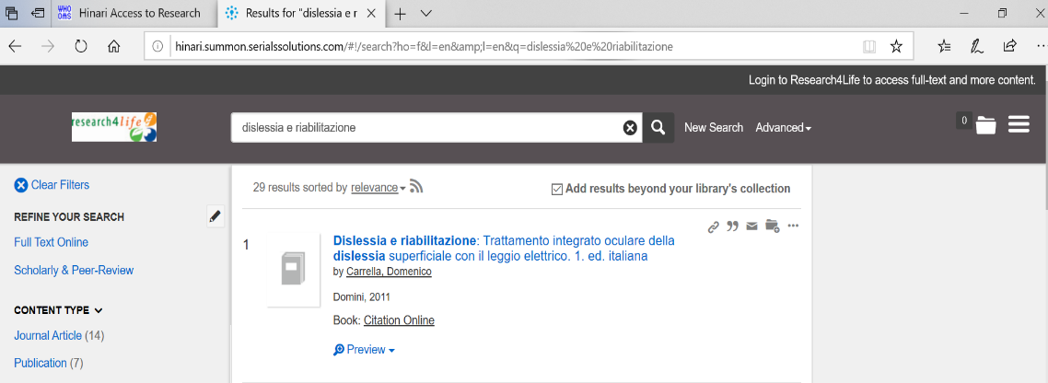](https://www.google.com/url?sa=t&rct=j&q=&esrc=s&source=web&cd=1&cad=rja&uact=8&ved=2ahUKEwit45OP-oTpAhXp_CoKHSwYCQIQFjAAegQIARAB&url=https%3A%2F%2Fnileuniversity-edu.com%2Fe-library-databases%2F&usg=AOvVaw1FUQvKerK4bIMW7TVCq8FM)