**1 SYDDANSK UNIVERSITETSBIBLIOTHEK – (**Odense M, Danimarca)

<http://syddansk.summon.serialssolutions.com/search?s.q=dislessia%20e%20riabilitazione#!/search?ho=f&l=da-DK&q=dislessia%20e%20riabilitazione>

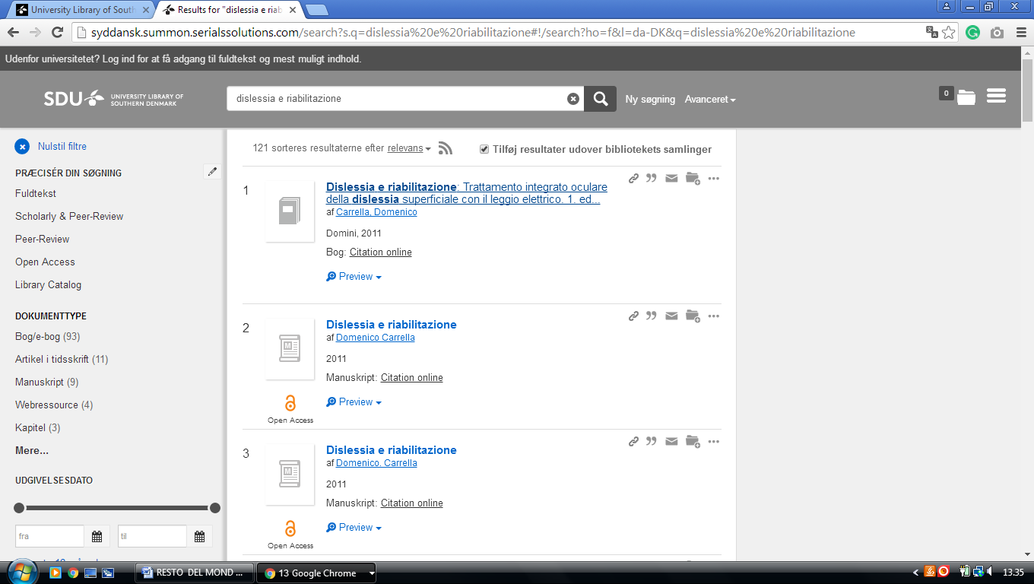

**2**  [**ROSKILDE UNIVERSITY**](http://rub.ruc.dk/) **LIBRARY** – (Roskilde, Denmark)

<https://rex.kb.dk/primo-explore/search?institution=KGL&vid=NUI&tab=default_tab&search_scope=RUC&mode=Basic&displayMode=full&bulkSize=10&highlight=true&dum=true&query=any,contains,dislessia%20e%20riabilitazione&displayField=all&pcAvailabiltyMode=true&sortby=rank&lang=da_DK&pcAvailability=true>

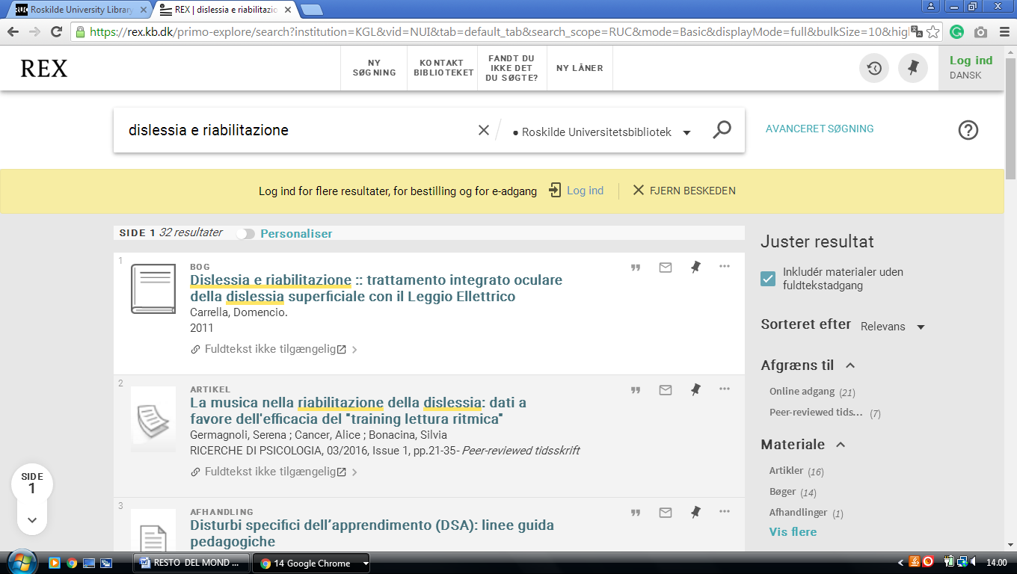

### 3 [THE UNIVERSITY LIBRARY - AAU](http://www.en.aub.aau.dk/) – ([Aalborg](https://it.wikipedia.org/wiki/Aalborg), Danimarca)

<http://primo.aub.aau.dk/primo_library/libweb/action/search.do?ct=facet&pcAvailabiltyMode=true&pcAvailClicked=true&vid=desktop&vl(57399064UI0)=any&ct=search&tab=default_tab&vl(57399062UI1)=all_items&fn=search&indx=1&dscnt=0&vl(freeText0)=dislessia%20e%20riabilitazione&vl(1UIStartWith0)=contains&dum=true&dstmp=1518618789089>

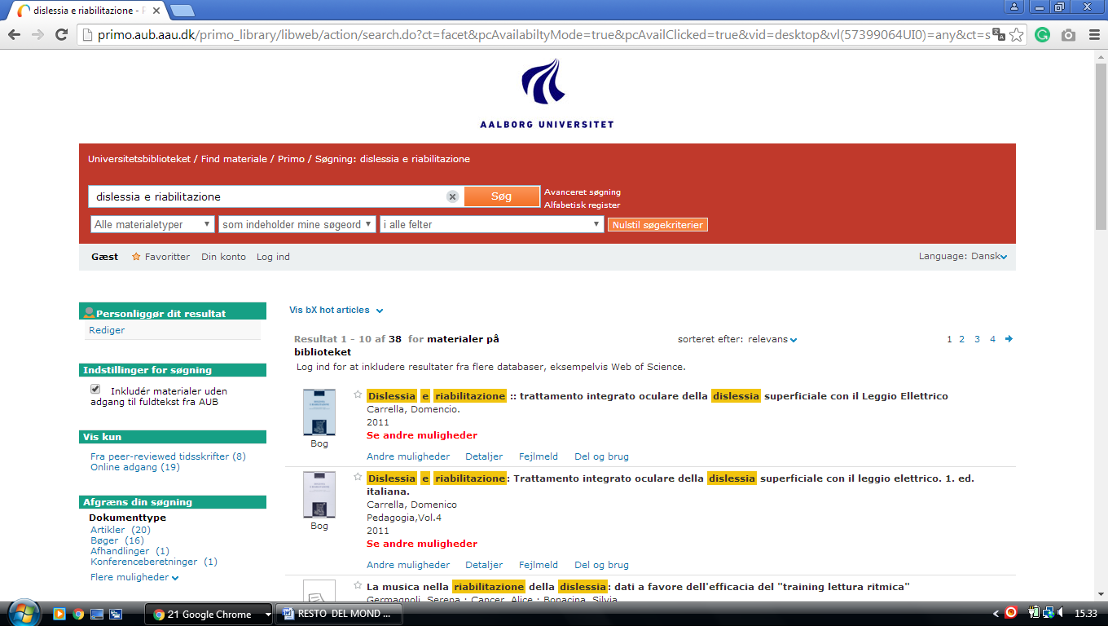

### 4 [COPENHAGEN UNIVERSITY LIBRARY FREDERIKSBERG – UNIVERSITY OF..](http://www.library.science.ku.dk/) (Copenhagen, Danimarca)

<https://rex.kb.dk/primo-explore/search?institution=KGL&vid=NUI&tab=default_tab&search_scope=KGL&mode=Basic&displayMode=full&bulkSize=10&highlight=true&dum=true&query=any,contains,dislessia%20e%20riabilitazione&displayField=all&pcAvailabiltyMode=true&sortby=rank&lang=da_DK&pcAvailability=true>

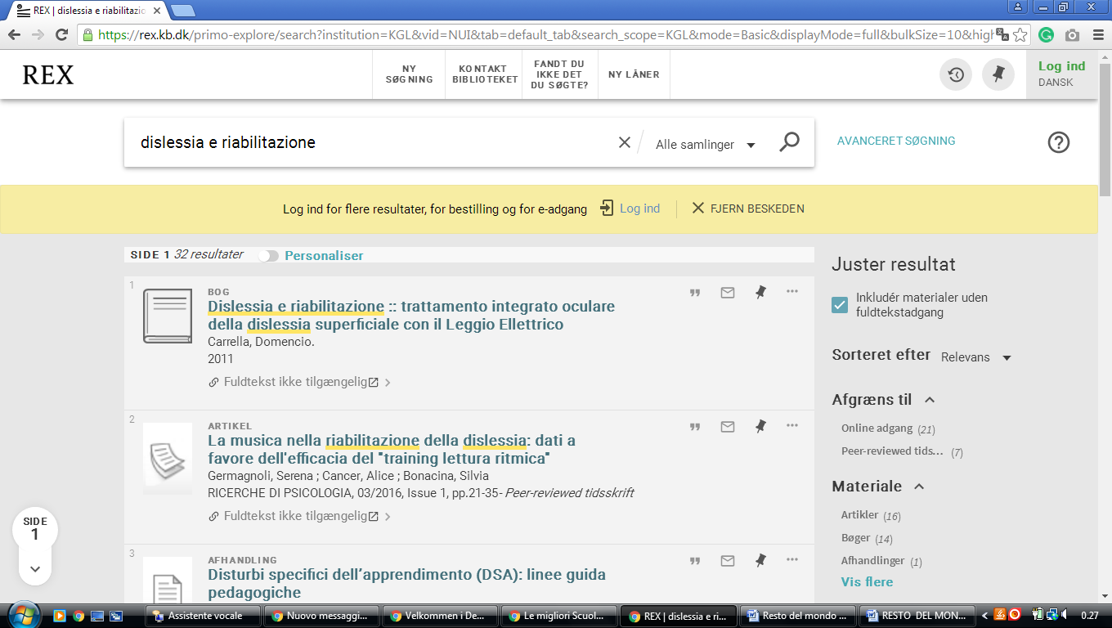

### 5 [HJEM - KUB NORD - INDEX AT THE ROYAL LIBRARY - DANSKE FAGSIDER](https://kub.kb.dk/kubnord), (Danimarca )

<https://rex.kb.dk/primo-explore/search?search=dislessia%20e%20riabilitazione&institution=KGL&vid=NUI&tab=default_tab&search_scope=KGL&mode=Basic&displayMode=full&bulkSize=10&highlight=true&dum=true&query=any,contains,dislessia%20e%20riabilitazione&displayField=all&pcAvailabiltyMode=true&sortby=rank&lang=da_DK&pcAvailability=true>

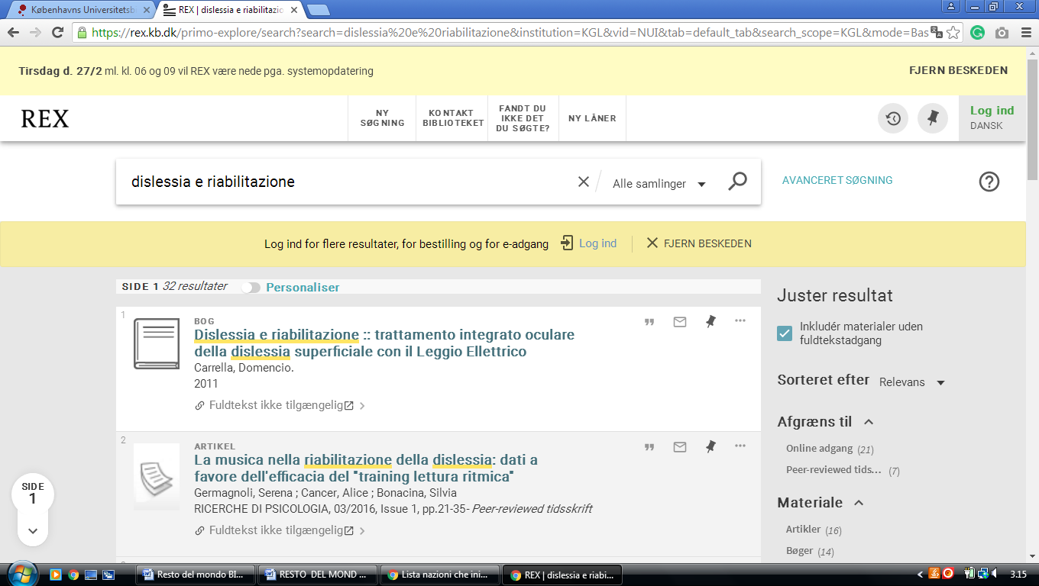

**Royal Library of Denmark (Bibliographies)**

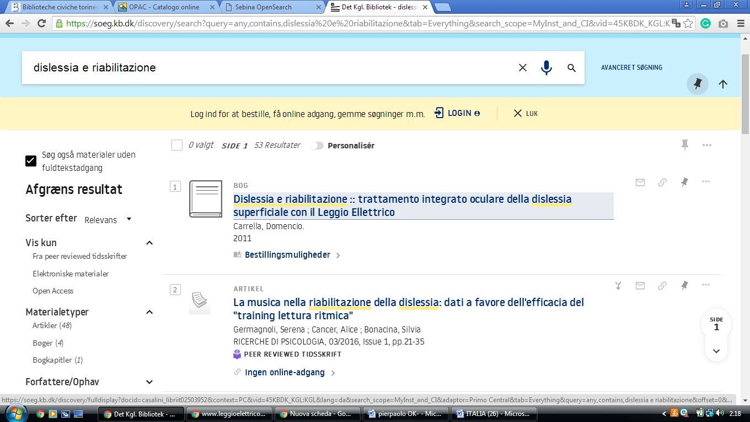<https://soeg.kb.dk/discovery/search?query=any,contains,dislessia%20e%20riabilitazione&tab=Everything&search_scope=MyInst_and_CI&vid=45KBDK_KGL:KGL&lang=da&offset=0&pcAvailability=true>

**Det Administrative Bibliotek Denmark**

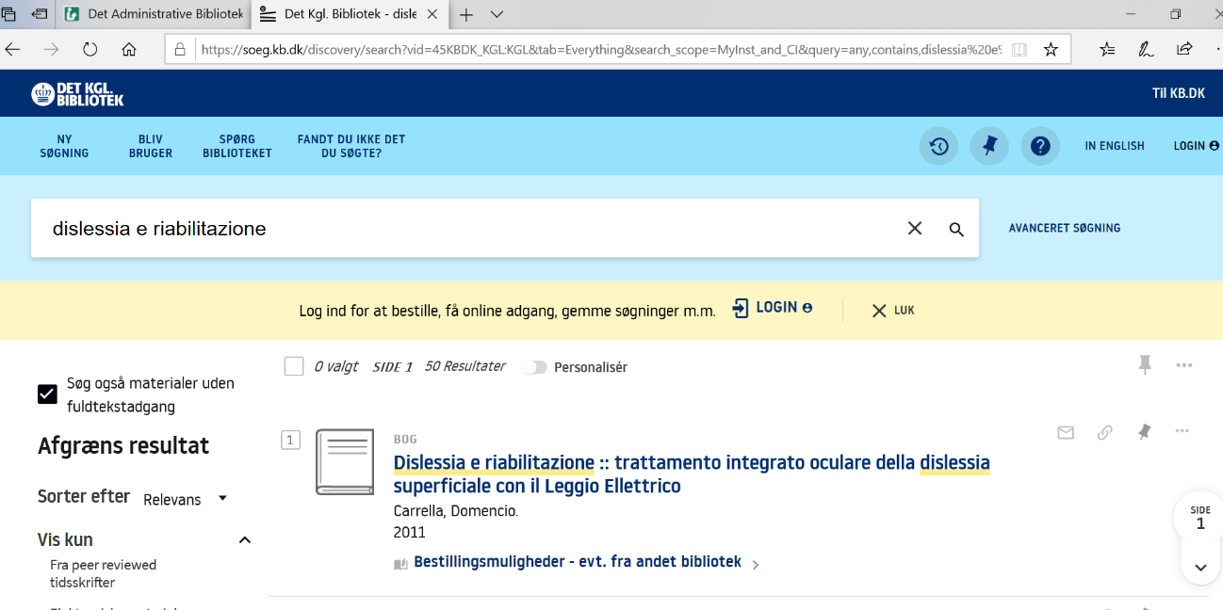https://soeg.kb.dk/discovery/search?vid=45KBDK_KGL:KGL&tab=Everything&search_scope=MyInst_and_CI&query=any,contains,dislessia%20e%20riabilitazione&lang=da&pcAvailability=true

### Delaware, USA