**1 B**[**IBLIOTECA DO INSTITUTO RUDJER BOSKOVIC**](http://nippur.irb.hr/)– (Croazia)

<http://eds.b.ebscohost.com/eds/detail/detail?vid=1&sid=41e62c25-85c9-479e-b0fb-cc01fddcb4b8%40sessionmgr102&bdata=Jmxhbmc9aHImc2l0ZT1lZHMtbGl2ZQ%3d%3d#db=edsbvb&AN=EDSBVB.BV039611798>

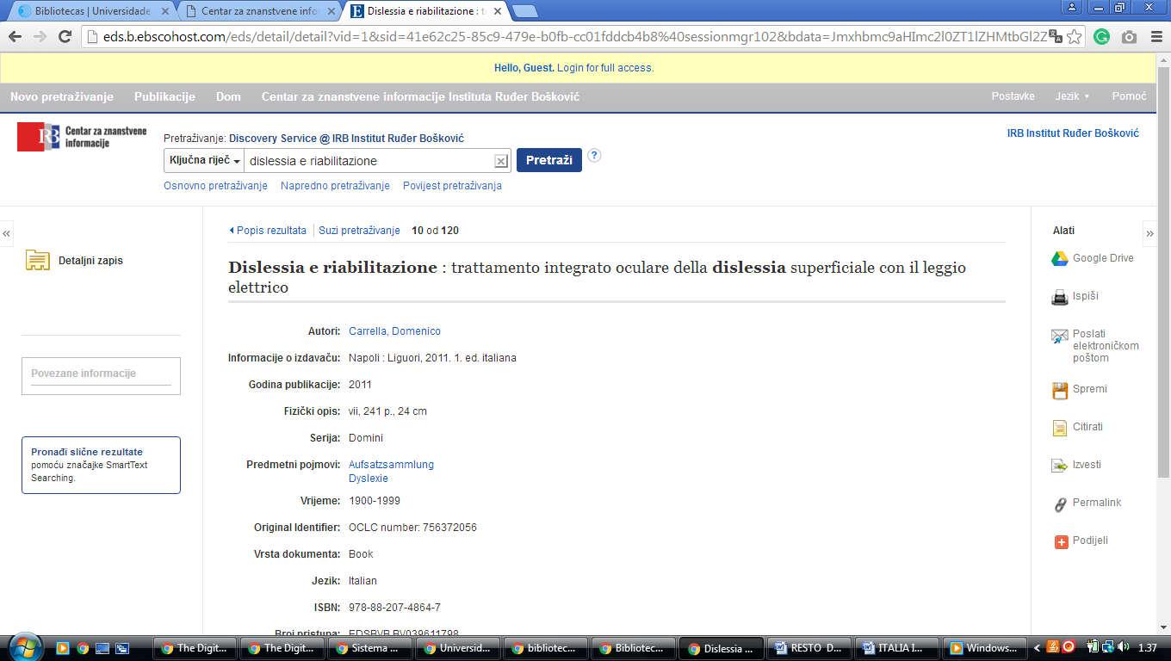

### 2 [NACIONALNA I SVEUČILIŠNA KNJIŽNICA U ZAGREBU – (Croazia)](http://www.nsk.hr/)

<http://haw.nsk.hr/>

<http://www.theeuropeanlibrary.org/tel4/search?query=dislessia%20e%20riabilitazione>

