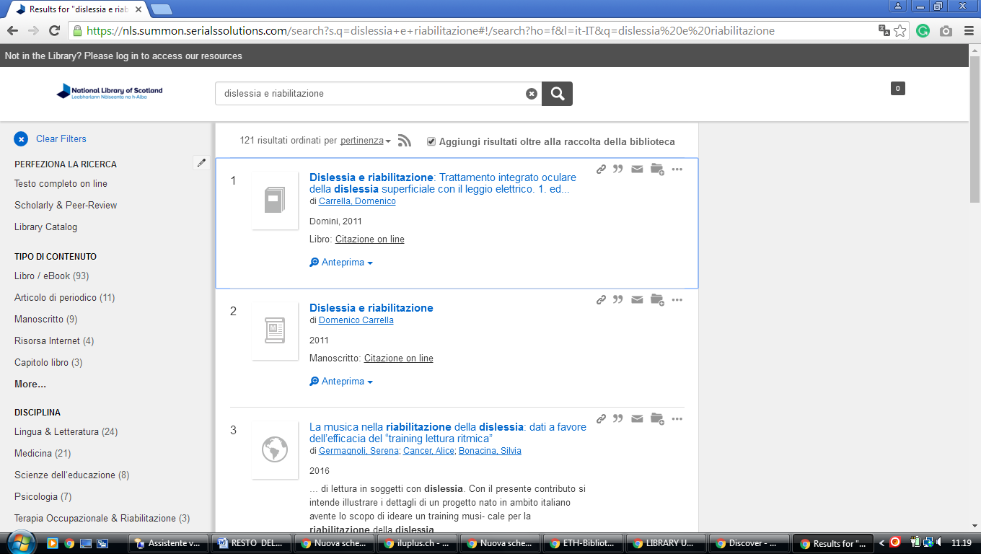**1**  [**AJOU UNIVERSITY**](http://library.ajou.ac.kr/) **LIBRARY -** (Suwon, South Korea)

<http://ajou.summon.serialssolutions.com/en/#!/search?ho=f&l=en&q=DISLESSIA%20E%20RIABILITAZIONE>

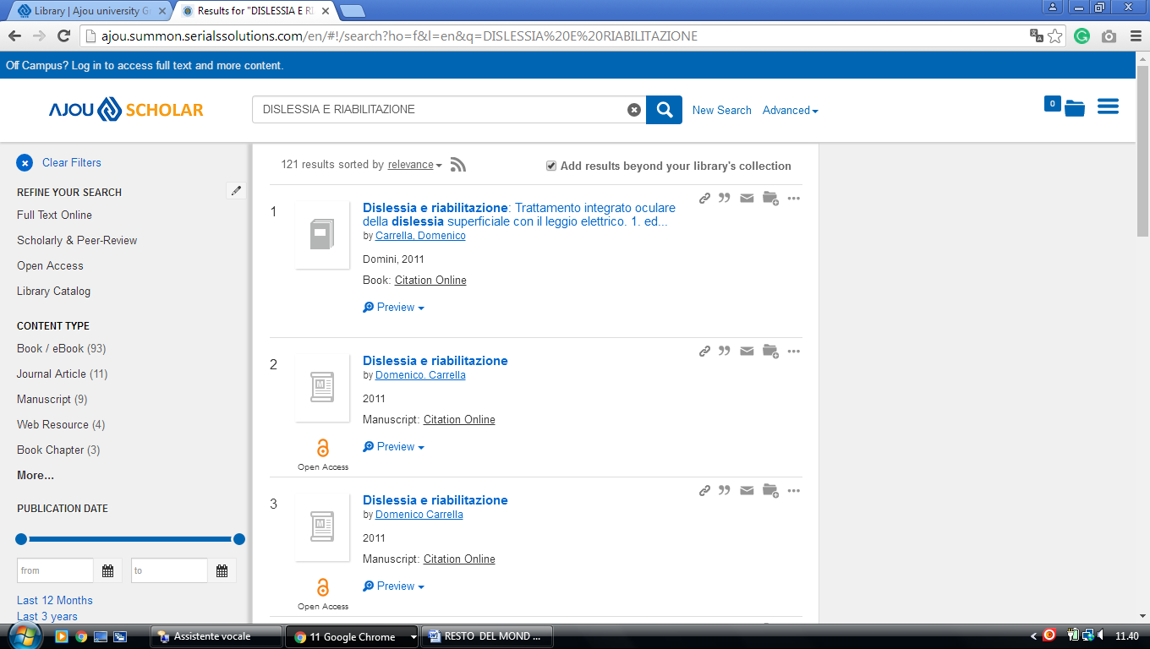

**2**  [**KYUNGSUNG UNIVERSITY**](http://library.ks.ac.kr/) **LIBRARY – (**Pusan, South Korea)

<http://kyungsung-primo.hosted.exlibrisgroup.com/primo_library/libweb/action/display.do?tabs=viewOnlineTab&ct=display&fn=search&doc=TN_casalini_libriit02503952&indx=1&recIds=TN_casalini_libriit02503952&recIdxs=0&elementId=0&renderMode=poppedOut&displayMode=full&frbrVersion=&frbg=&pcAvailabiltyMode=true&dscnt=0&scp.scps=scope%3A%28KSU_SFX%29%2Cscope%3A%28KSU%29%2Cprimo_central_multiple_fe&tb=t&vid=KSU&mode=Basic&tab=default_tab&srt=rank&dum=true&vl(freeText0)=DISLESSIA%20E%20RIABILITAZIONE&dstmp=1498182096743>

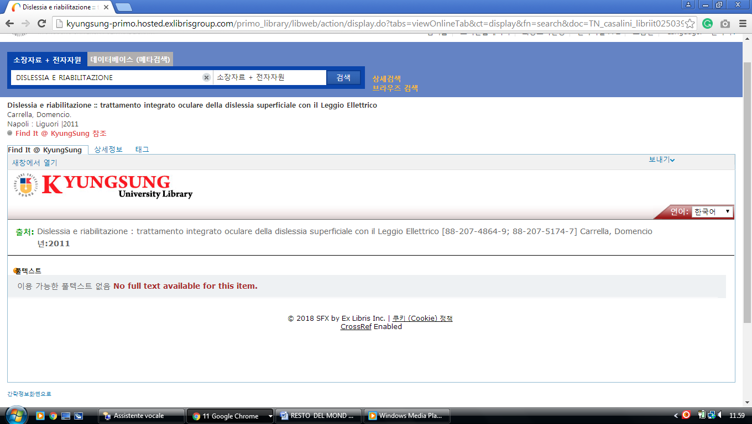

**3** [**KHIS.SUMMON.SERIALSSOLUTIONS.COM**](http://khis.summon.serialssolutions.com)– (Khu Library Korea)

<http://khis.summon.serialssolutions.com/?q=dislessia+e+riabilitazione#!/search?ho=f&l=en&q=dislessia%20e%20riabilitazione>

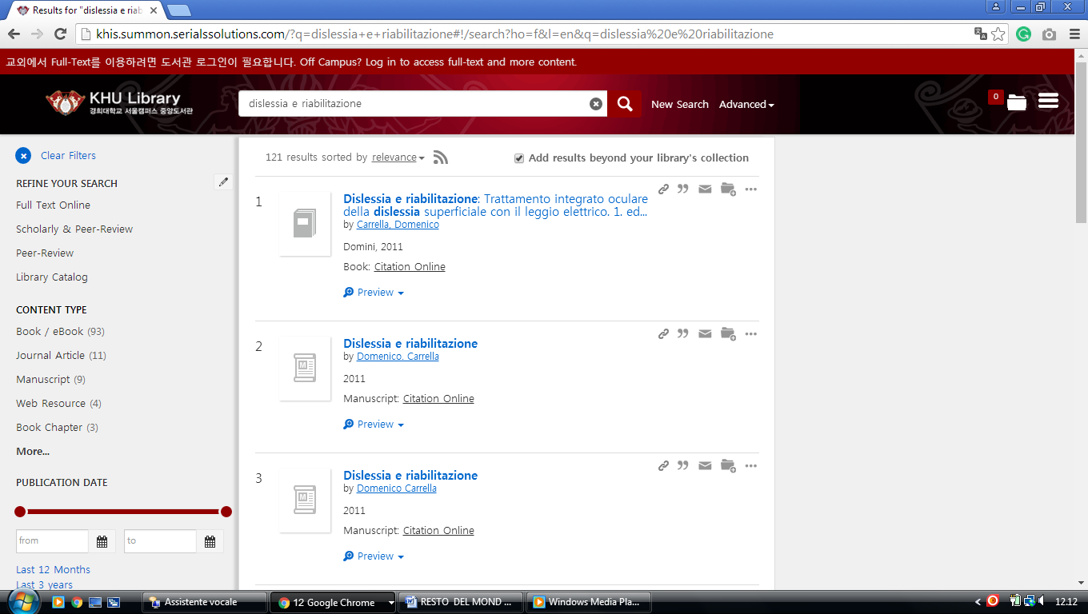

**4 LIBRARY.YONSEI.AC.KR/EN -** (University, [Seodaemun-Gu](https://en.wikipedia.org/wiki/Seodaemun-gu), [Seoul](https://en.wikipedia.org/wiki/Seoul" \o "Seoul),[South Korea](https://en.wikipedia.org/wiki/South_Korea))

<http://yonsei.summon.serialssolutions.com/?q=DISLESSIA+E+RIABILITAZIONE&x=17&y=38#!/search?ho=f&l=it-IT&q=DISLESSIA%20E>

%20RIABILITAZIONE&x=17&y=38

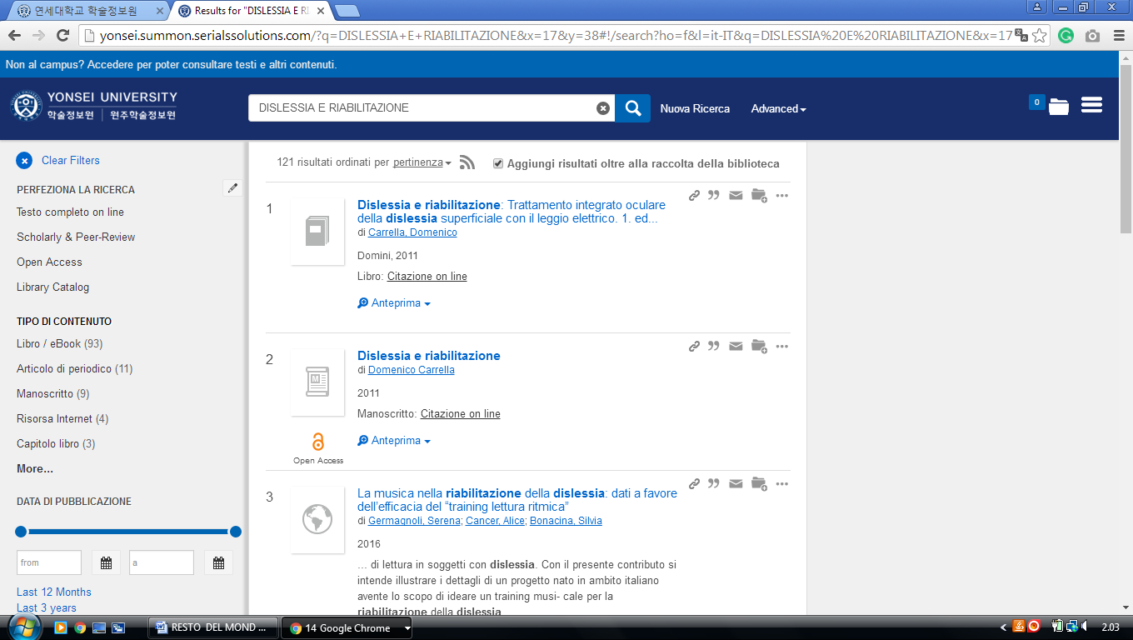

**5** [**KYUNGPOOK NATIONAL UNIVERSITY LIBRARY - 경북대학교 도서관**](http://kudos.knu.ac.kr/eng/)

(Repubblica di Corea)

<http://knu.summon.serialssolutions.com/search?s.q=+++dislessia+e+riabilitazione#!/search?ho=f&l=en&q=%20%20%20dislessia%20e%20riabilitazione>

