### [1 EUROPEAN UNIVERSITY CYPRUS - LIBRARY](http://www.euc.ac.cy/en/about-us/library) – (Cipro)

<http://eds.a.ebscohost.com/eds/results?vid=1&sid=58b801a0-7e8a-46e5-a17c-f60ba3e9b734%40sessionmgr4006&bquery=(dislessia+AND+e+AND+riabilitazione)&bdata=JnR5cGU9MCZzaXRlPWVkcy1saXZl>

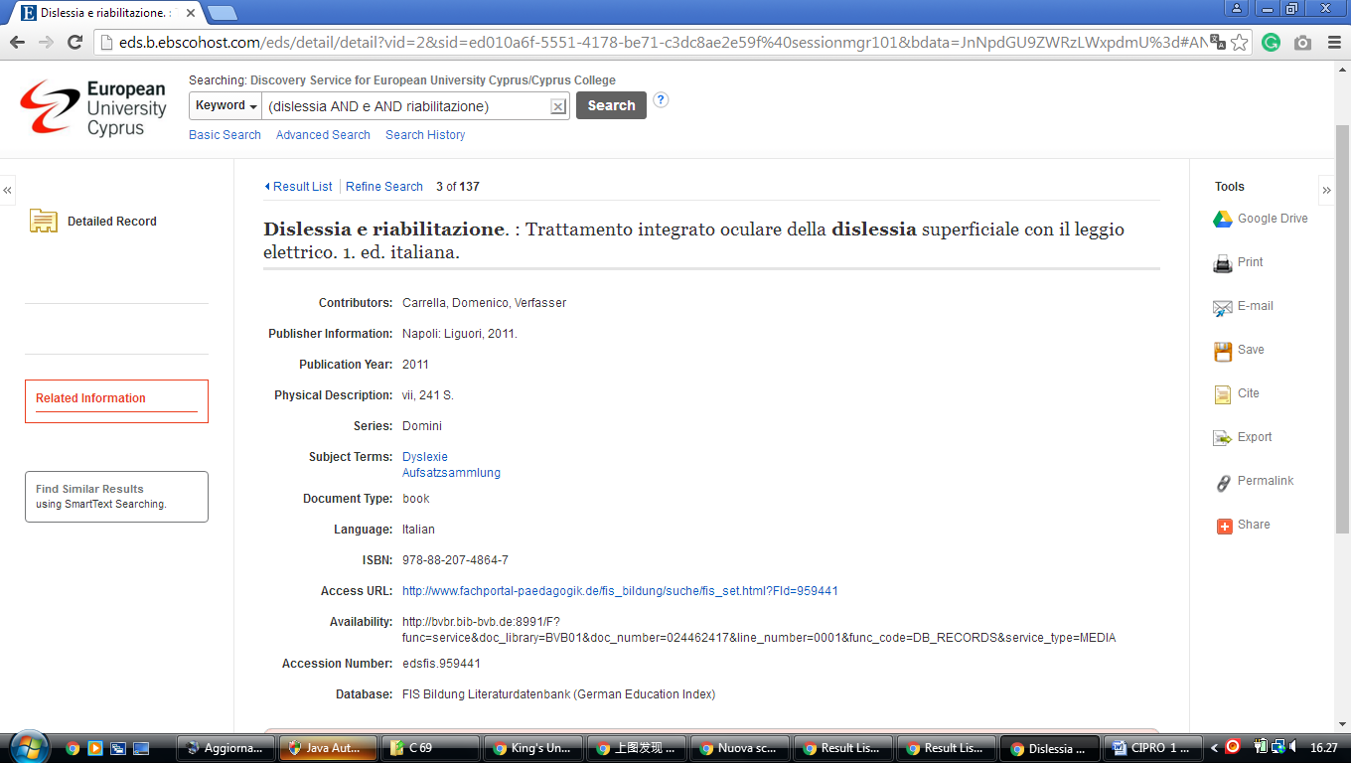

[**Library Hours | Library, University of Cyprus**](http://library.ucy.ac.cy/en/library/opening-hours)

http://eds.b.ebscohost.com/eds/results?vid=2&sid=43ee6c7d-060a-4d36-b53d-7041fe4992a1%40pdc-v-sessmgr04&bquery=dislessia+e+riabilitazione&bdata=JmNsaTA9RlQxJmNsdjA9WSZ0eXBlPTAmc2VhcmNoTW9kZT1TdGFuZGFyZCZzaXRlPWVkcy1saXZl

