**1**  [**BRITISH COLUMBIA INSTITUTE OF TECHNOLOGY**](http://www.bcit.ca/library/) **LIBRARY – (**Burnaby, Canada)

<https://bcit.summon.serialssolutions.com/search?s.q=dislessia+e+riabilitazione&spellcheck=true&keep_r=true#!/search?ho=f&l=en&q=dislessia%20e%20riabilitazione>

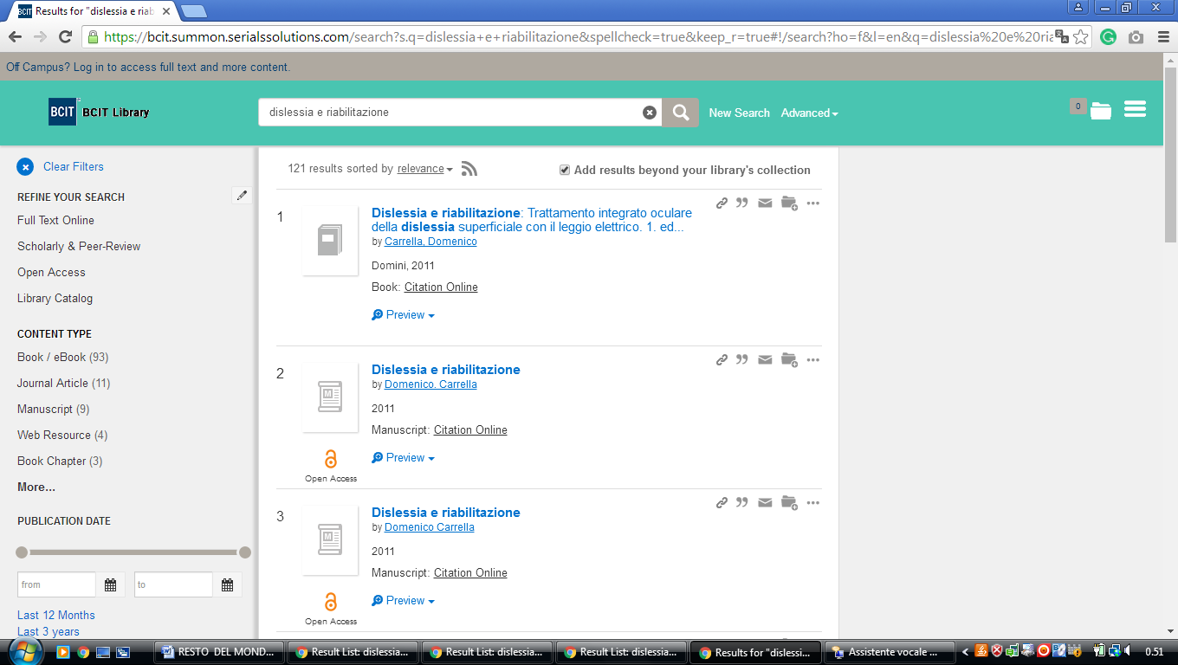

**2** [**UNIVERSITY OF BRITISH COLUMBIA LIBRARY –**](http://www.library.ubc.ca/)  **(**Vancover In British Colombia, Canada)

<http://ubc.summon.serialssolutions.com/search?spellcheck=true&s.q=dislessia+e+riabilitazione#!/search?ho=f&l=en&q=dislessia%20e%20riabilitazione>

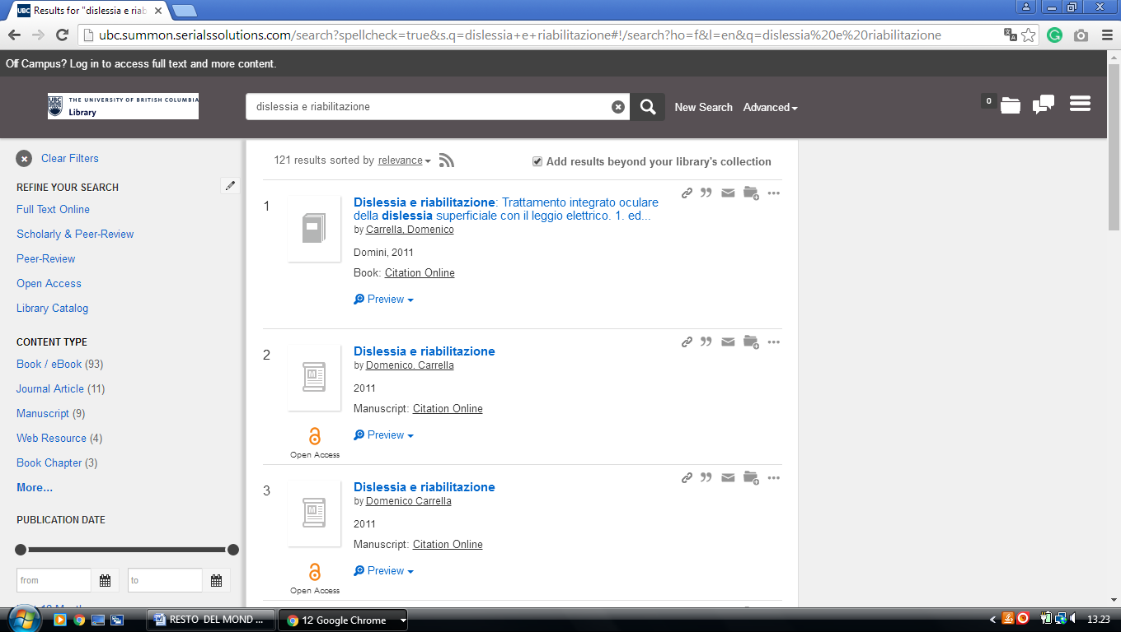

**3** [**GEOFFREY R. WELLER LIBRARY**](http://library.unbc.ca/) - (Prince George, British Columbia, Canada)

[http://unbc.summon.serialssolutions.com/search?s.q=dislessia+e+riabilitaziones.fvf[]=ContentType,CNewspaper+Article,t&s.fvf[]=ContentType,Book+Review,t&keep_r=true#!/search?ho=f&fvf=ContentType,Newspaper%20Article,t%7CContentType,Book%20Review,t&l=en&q=dislessia%20e%20riabilitazione](http://unbc.summon.serialssolutions.com/search?s.q=dislessia+e+riabilitaziones.fvf%5b%5d=ContentType,CNewspaper+Article,t&s.fvf%5b%5d=ContentType,Book+Review,t&keep_r=true#!/search?ho=f&fvf=ContentType,Newspaper%20Article,t%7CContentType,Book%20Review,t&l=en&q=dislessia%20e%20riabilitazione)

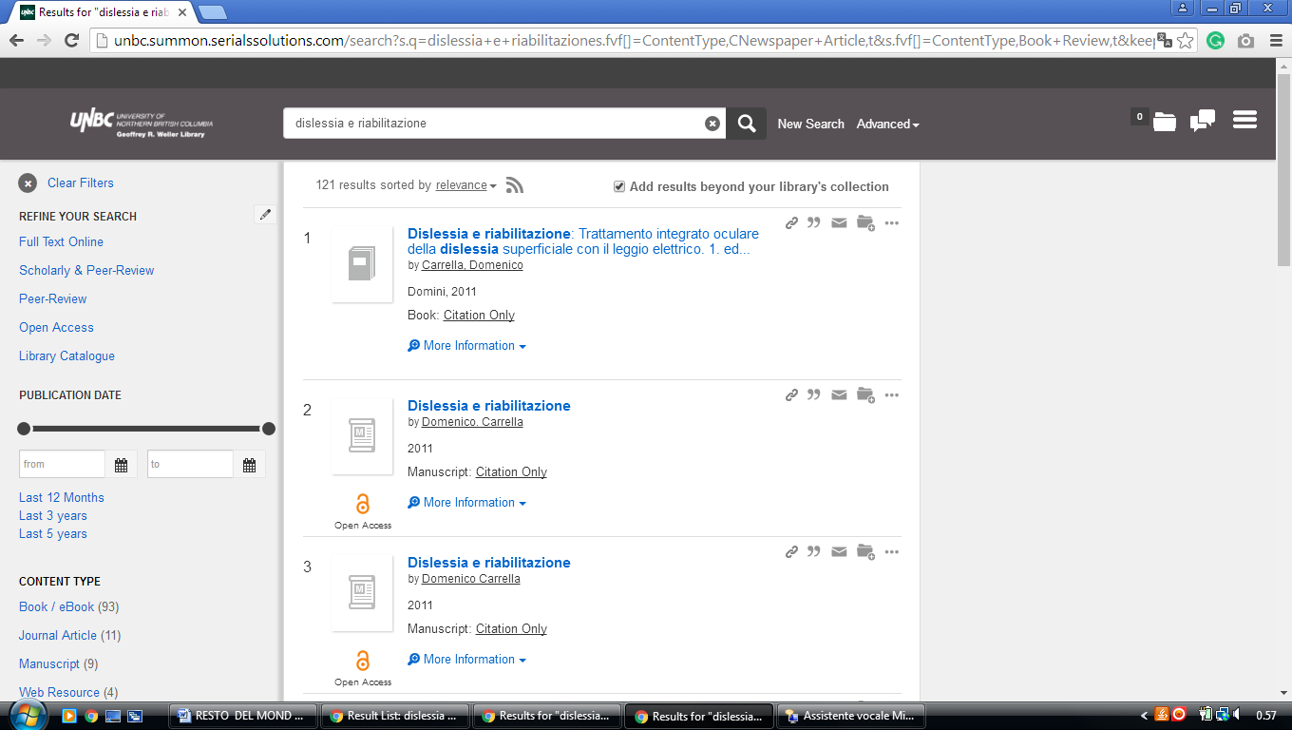

**4 UNIVERSITY OF LETHBRIDGE LIBRARY – (**[Alberta](https://en.wikipedia.org/wiki/Alberta), Canada)

<https://uleth.summon.serialssolutions.com/?#!/search?ho=f&l=en-UK&q=dislessia%20e%20riabilitazione>

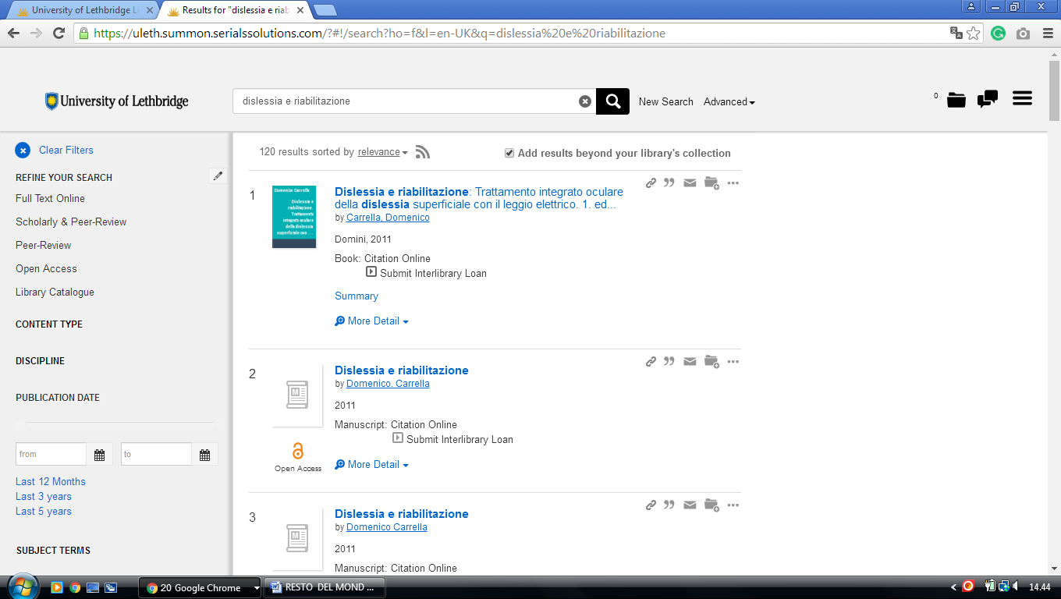

**5** [**OKANAGAN COLLEGE LIBRARY**](http://www.okanagan.bc.ca/administration/students/library.html) **– (**Kelowna, British Columbia, Canada)

<http://eds.b.ebscohost.com/eds/results?vid=3&sid=1aa623ac-e021-414e-947b-f008c1c88f27%40sessionmgr120&bquery=(dislessia+AND+e+AND+riabilitazione)&bdata=JnR5cGU9MCZzaXRlPWVkcy1saXZlJnNjb3BlPXNpdGU%3d>

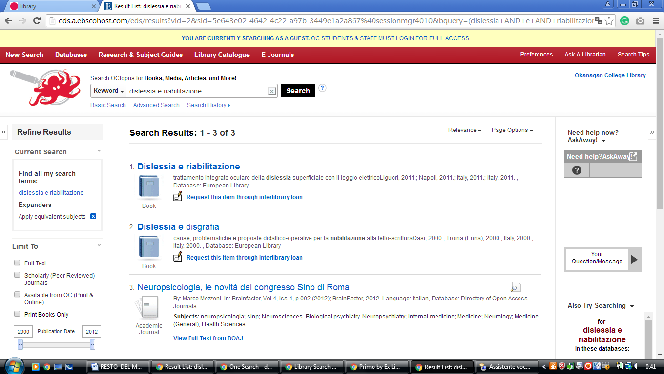

**6** [**RRU LIBRARY**](http://library.royalroads.ca/) **–** (Victoria, British Columbia, Canada)

<https://royalroads.on.worldcat.org/search?sortKey=BEST_MATCH&databaseList=&queryString=dislessia+e+riabilitazione&changedFacet=scope&scope=&scope=wz%3A26145&format=all&database=all&author=all&year=all&yearFrom=&yearTo>=

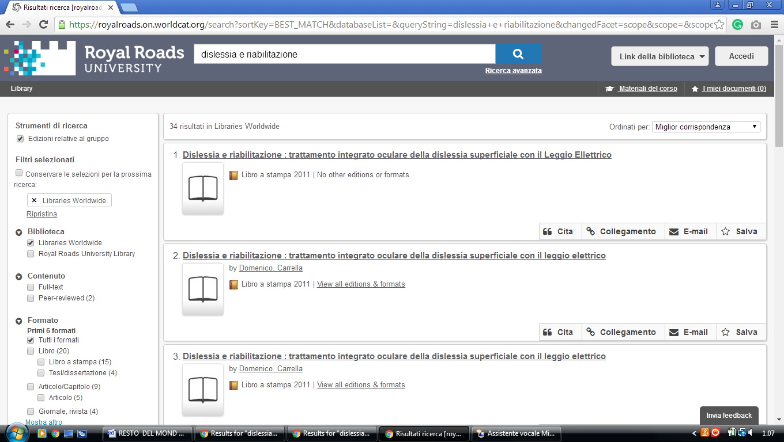

**7**  [**VANCOUVER ISLAND UNIVERSITY LIBRARY**](http://www.viu.ca/library/index.asp) **–** (Nanaimo, British Columbia, Canada)

<http://viu.summon.serialssolutions.com/search?s.q=dislessia+e+riabilitazione&s.fvf%5B%5D=ContentType%2CBook+Review%2Ct&x=9&y=15#!/search?ho=f&fvf=ContentType,Book%20Review,t&l=en&q=dislessia%20e%20riabilitazione>

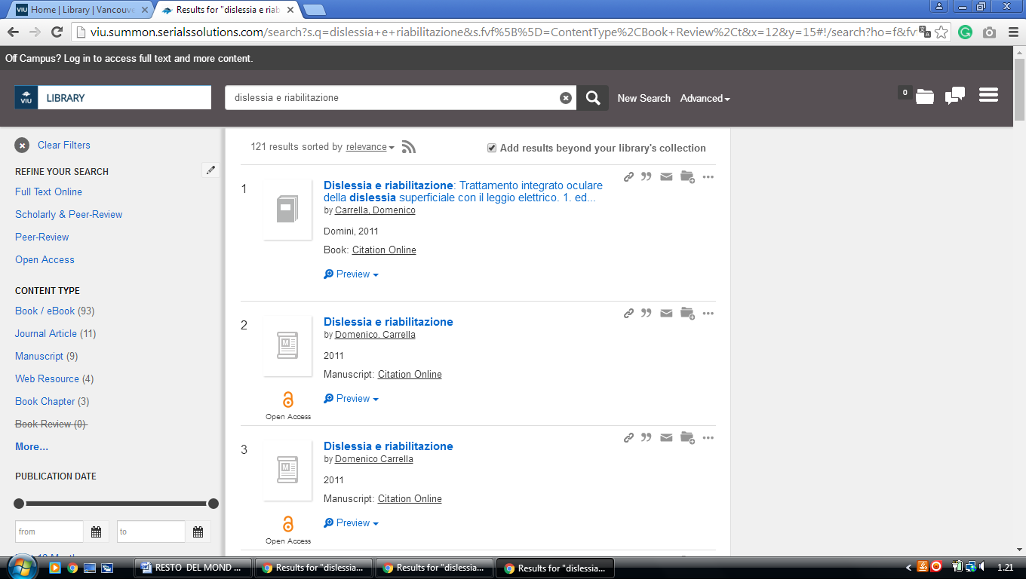

**8**  [**UNIVERSITY OF VICTORIA LIBRARIES**](http://library.uvic.ca/index.html) **-**  (Victoria, British Columbia, Canada)

<http://uvic.summon.serialssolutions.com/#!/search?ho=f&l=en&q=dislessia%20e%20riabilitazione>

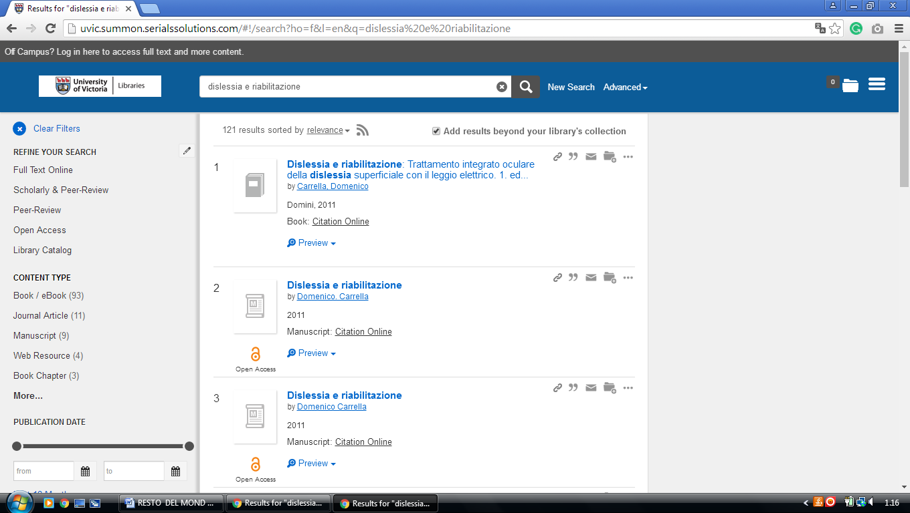

**9** [**KWANTLEN UNIVERSITY COLLEGE LIBRARY**](http://www.kwantlen.bc.ca/library.html) **–** (Surrey, British Columbia, Canada)

<http://kwantlen.summon.serialssolutions.com/?spellcheck=true&s.q=dislessia+e+riabilitazione#!/search?ho=f&l=en&q=dislessia%20e%20riabilitazione>

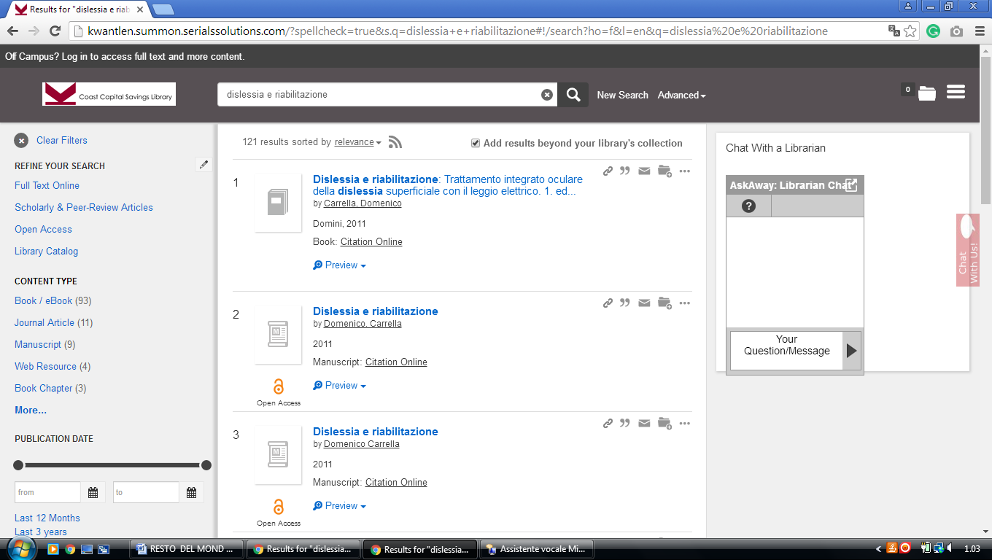

### 10 LIBRARY - CONCORDIA UNIVERSITY OF EDMONTON - (Edmonton Canada)

<https://concordia.on.worldcat.org/search?sortKey=LIBRARY&databaseList=&queryString=dislessia+e+riabilitazione&changedFacet=scope&scope=&scope=sz%3A32485&format=all&database=all&author=all&year=all&yearFrom=&yearTo=&language=all>

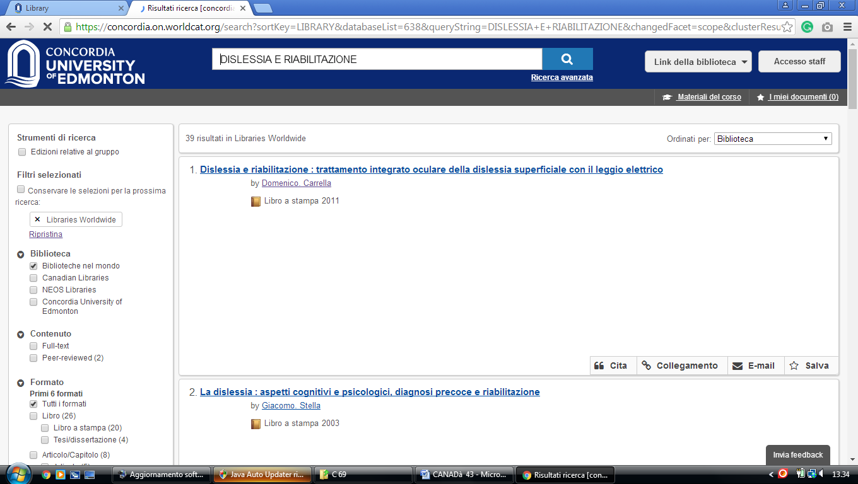

**11** [**LIBRARY AT UNIVERSITY OF CALGARY**](https://library.ucalgary.ca/) – ([Alberta](https://en.wikipedia.org/wiki/Alberta), [Canada](https://en.wikipedia.org/wiki/Canada))

### <https://ucalgary.summon.serialssolutions.com/search?q=dislessia+e+riabilitazione#!/search?ho=f&l=en&q=dislessia%20e%20riabilitazione>

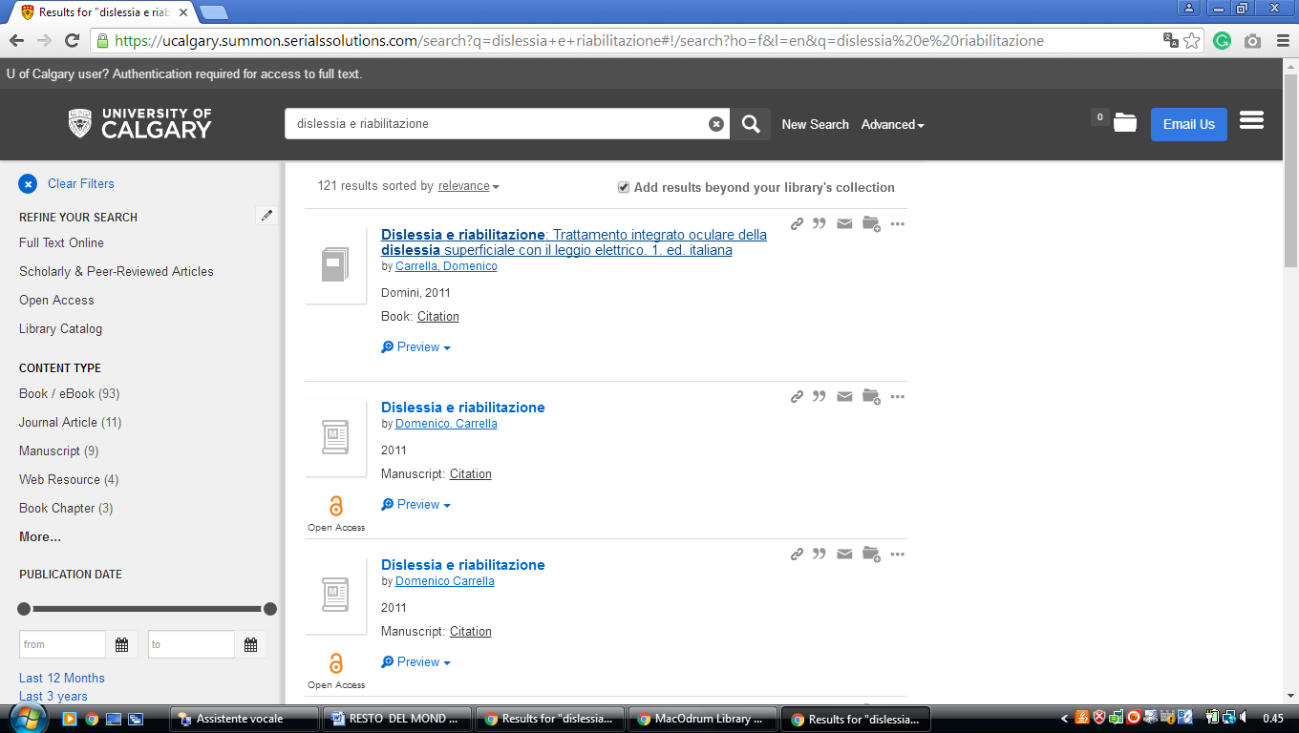

### 12 [CENTENNIAL COLLEGE LIBRARIES](http://library.centennialcollege.ca/) – ([Ontario](https://en.wikipedia.org/wiki/Ontario), Canada)

<http://centennial.summon.serialssolutions.com/search?s.q=dislessia+e+riabilitazione#!/search?ho=f&l=it-IT&q=dislessia%20e%20riabilitazione>

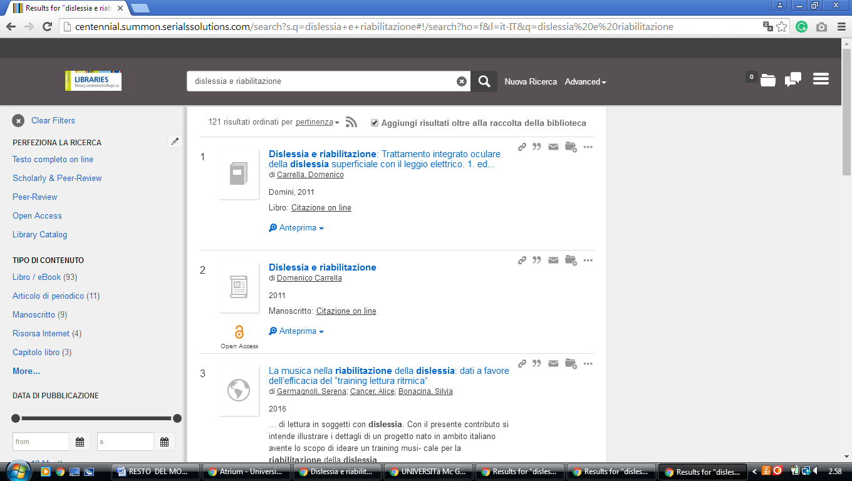

**13 [GEOFFREY R. WELLER LIBRARY - UNIVERSITY OF NORTHERN BRITISH](https://library.unbc.ca/)**

### [COLUMBIA](https://library.unbc.ca/) - ([Prince George](https://en.wikipedia.org/wiki/Prince_George,_British_Columbia), [British Columbia](https://en.wikipedia.org/wiki/British_Columbia), Canada)

[http://unbc.summon.serialssolutions.com/search?s.q=dislessia+e+riabilitaziones.fvf[]=ContentType,CNewspaper+Article,t&s.fvf[]=ContentType,Book+Review,t&keep_r=true#!/search?ho=f&fvf=ContentType,Newspaper%20Article,t%7CContentType,Book%20Review,t&l=en&q=dislessia%20e%20riabilitazione](http://unbc.summon.serialssolutions.com/search?s.q=dislessia+e+riabilitaziones.fvf%5b%5d=ContentType,CNewspaper+Article,t&s.fvf%5b%5d=ContentType,Book+Review,t&keep_r=true#!/search?ho=f&fvf=ContentType,Newspaper%20Article,t%7CContentType,Book%20Review,t&l=en&q=dislessia%20e%20riabilitazione)

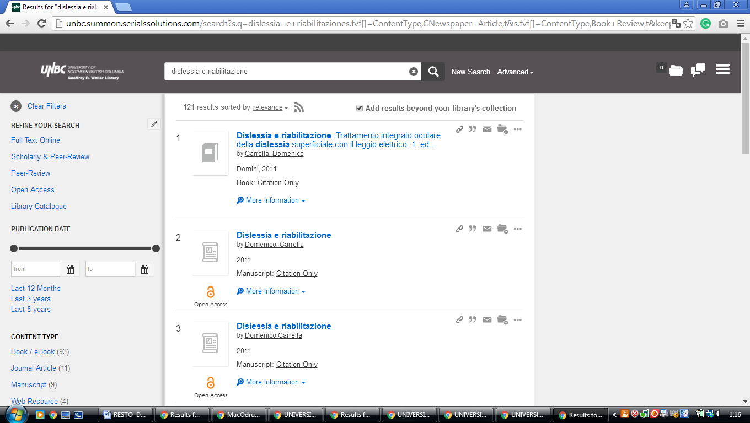

**14** [**MEDICINE HAT COLLEGE**](http://www.mhc.ab.ca/library/)**,LIBRARIES – (**Medicine Hat, Alberta, Canada)

<https://mhc.on.worldcat.org/external-search?queryString=dislessia+e+riabilitazione>

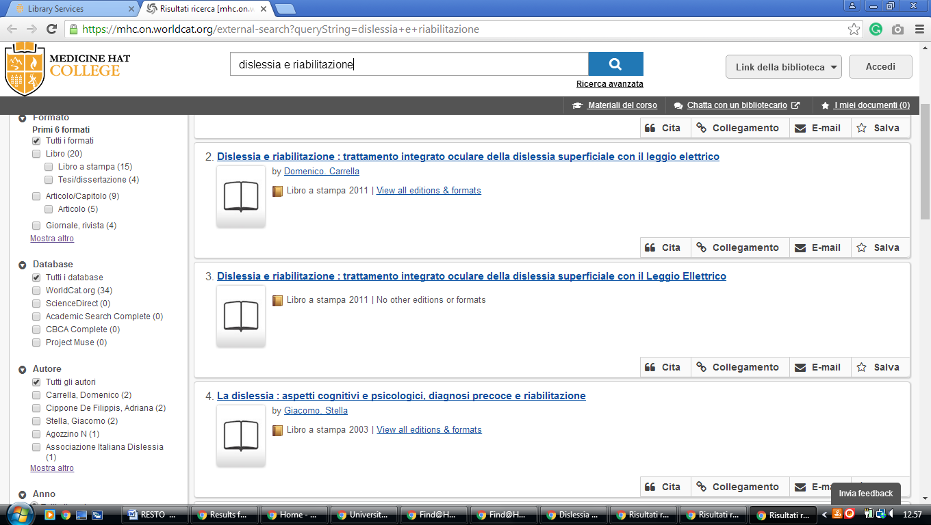

**15 UNIVERSITY OF LETHBRIDGE LIBRARY** – ([Alberta](https://en.wikipedia.org/wiki/Alberta), Canada)

<https://uleth.summon.serialssolutions.com/?#!/search?ho=f&l=en-UK&q=dislessia%20e%20riabilitazione>

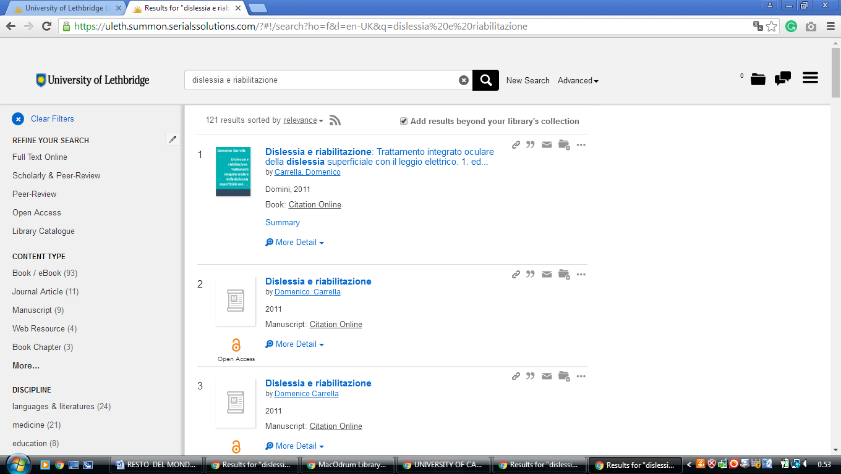

**16 MACODRUM LIBRARY CARLETON UNIVERSITY – (**[Ottawa](https://it.wikipedia.org/wiki/Ottawa), Canada)

<https://carletonu.summon.serialssolutions.com/?q=dislessia%20e%20riabilitazione#!/search?ho=f&l=en&q=dislessia%20e%20riabilitazione>

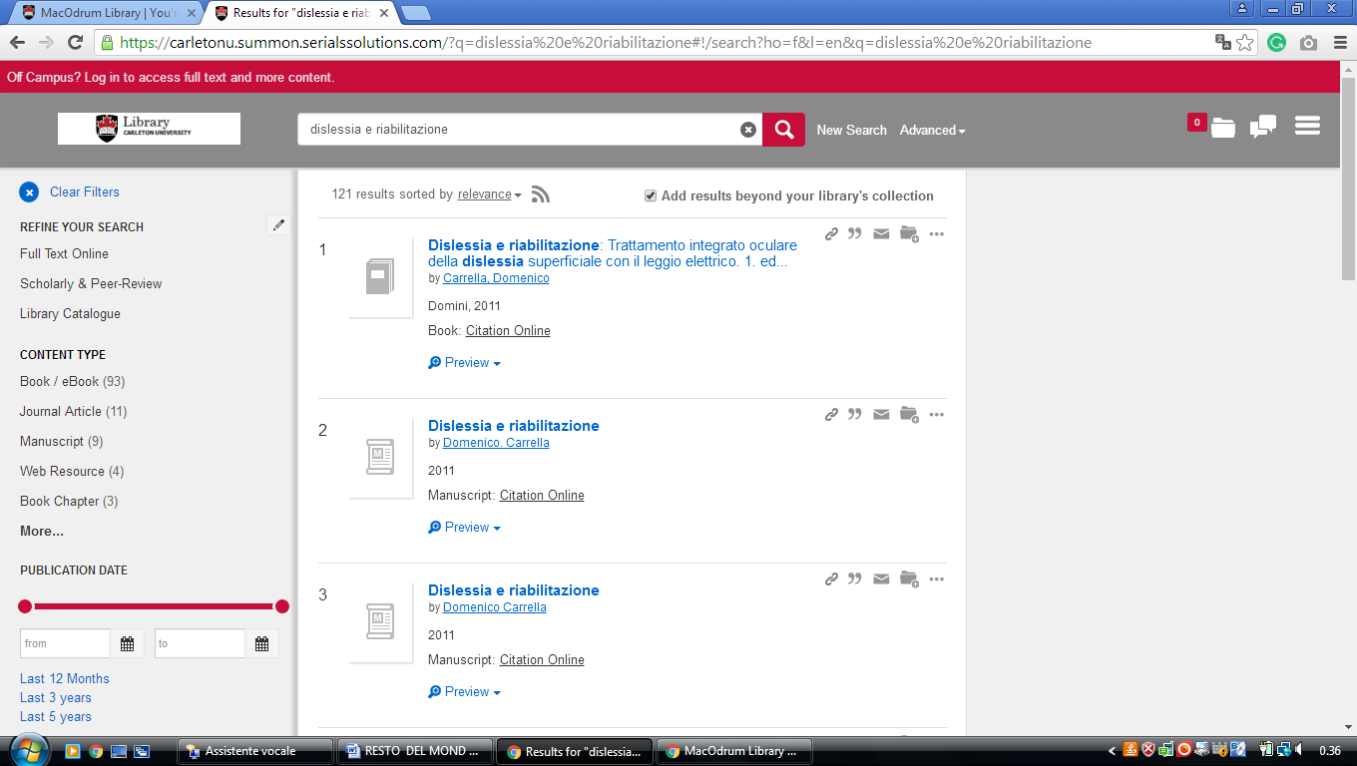

### 17 [MCGILL LIBRARY - MCGILL UNIVERSITY](http://www.mcgill.ca/library/) - (Montreal Canada)

<http://mcgill.worldcat.org/title/dislessia-e-riabilitazione-trattamento-integrato-oculare-della-dislessia-superficiale-con-il-leggio-elettrico/oclc/878784487&referer=brief_results>

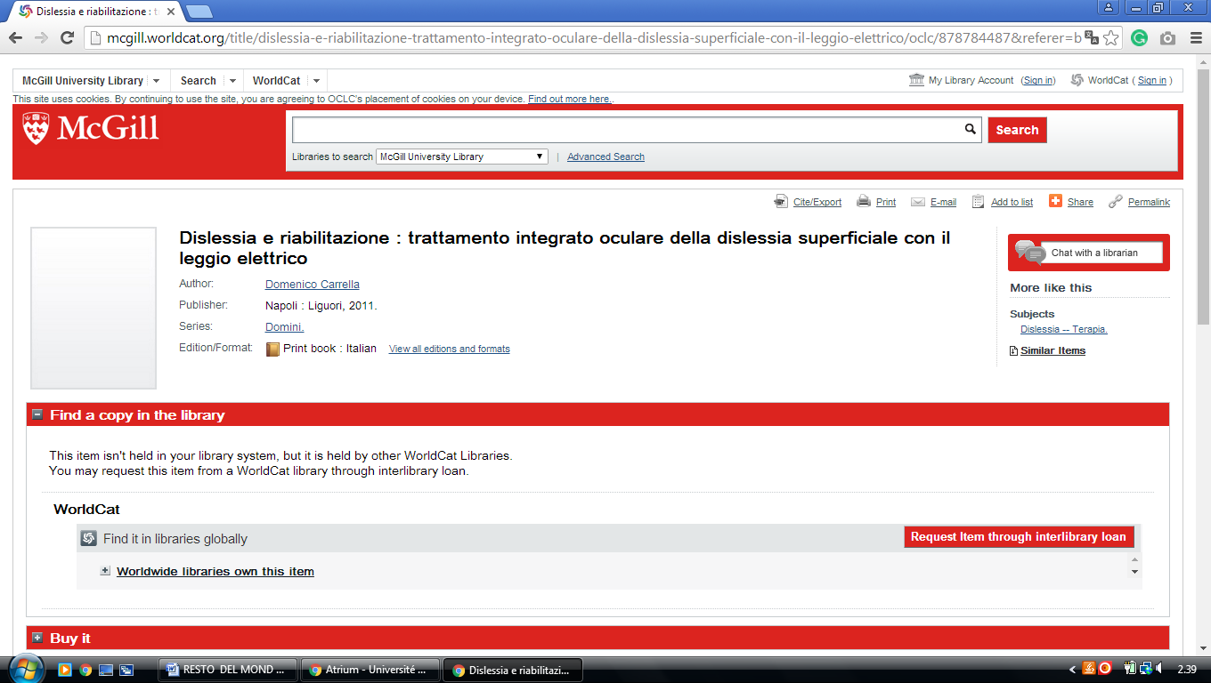

18 [**UNIVERSITY**](https://www.google.it/url?sa=t&rct=j&q=&esrc=s&source=web&cd=1&cad=rja&uact=8&ved=0ahUKEwjZi9z07YPSAhUKExoKHVF5D5AQFggaMAA&url=https%3A%2F%2Fwww.mcgill.ca%2Flibrary%2Flibrary-and-collections&usg=AFQjCNFIJDa6-BhJizs3X_Khdz5PaOjp0A) **IN MONTREAL LIBRARY – (**Quebec, Montreal)

<http://atrium.umontreal.ca/primo-explore/search?query=any,contains,DISLESSIA%20E%20RIABILITAZIONE&tab=tout_plus_articles&search_scope=Tout&vid=UM&lang=fr_FR&offset=0&sortby=rank&pcAvailability=true>

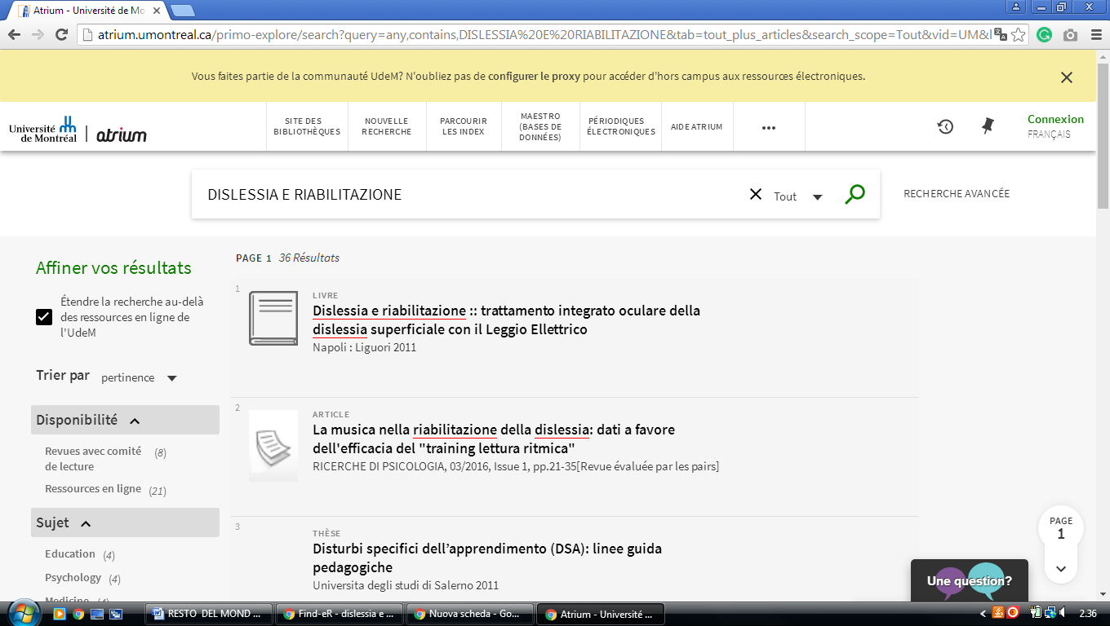

**19** [**MOUNT ROYAL COLLEGE**](http://www.mtroyal.ca/Library/index.htm) **LIBRARY -** (Calgary, Alberta, Canada)

<https://mtroyal.summon.serialssolutions.com/?fvf=ContentType%2CNewspaper+Article%2Ct&fvf=ContentType%2CBook+Review%2Ct&q=dislessia+e+riabilitazione#!/search?ho=f&fvf=ContentType,Newspaper%20Article,t%7CContentType,Book%20Review,t&l=en&q=dislessia%20e%20riabilitazione>

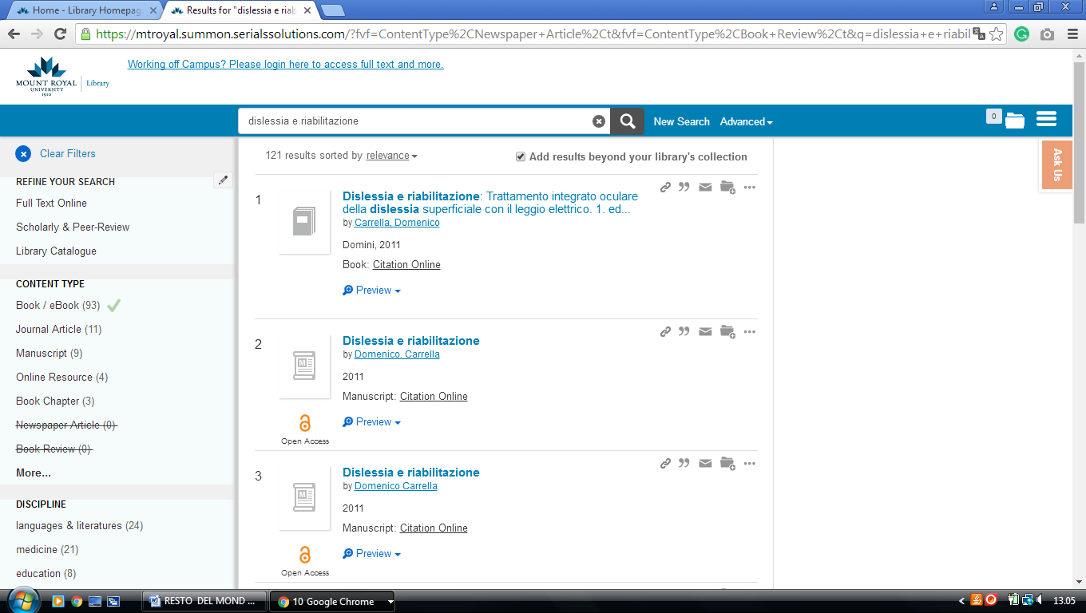

**20** [**UNIVERSITY OF MANITOBA LIBRARIES**](http://umanitoba.ca/libraries/) **– (**Winnipeg, Canada)

<http://primo-pmtna01.hosted.exlibrisgroup.com/primo_library/libweb/action/search.do?ct=facet&pcAvailabiltyMode=true&pcAvailClicked=true&query=any%2Ccontains%2C%20dislessia%20e%20riabilitazione&fn=search&indx=1&search_scope=UManitoba&dscnt=0&scp.scps=scope%3A(UMB)%2Cscope%3A(UMB_CR)%2Cscope%3A(UMB_MSPACE)%2Cscope%3A(UMB_LibGuides_OAI)%2Cprimo_central_multiple_fe&displayMode=full&vl(189744081UI0)=any&mode=Basic&onCampus=true&vid=UMB&queryTemp=%20dislessia%20e%20riabilitazione&institution=UMB&ct=search&highlight=true&tab=default_tab&displayField=all&vl(freeText0)=%20dislessia%20e%20riabilitazione&group=GUEST&dstmp=1518220758793&fromDL>

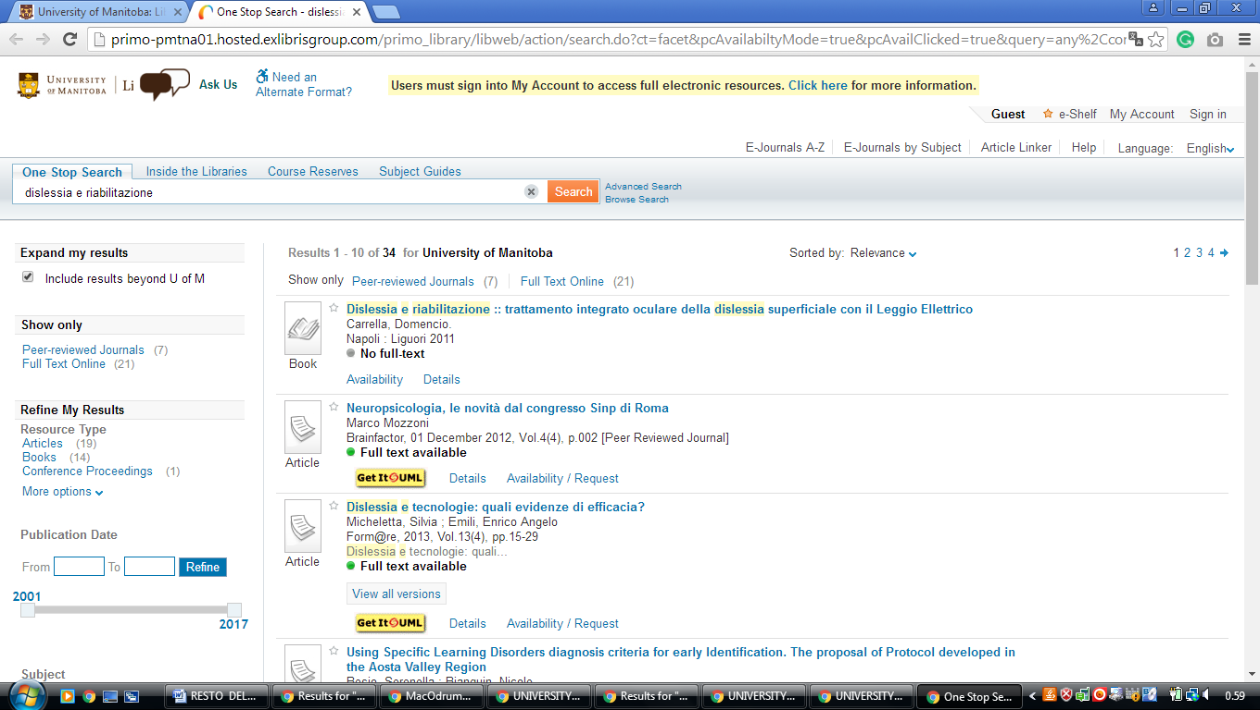

### 21 [LIBRARY - UNIVERSITY OF ONTARIO INSTITUTE OF TECHNOLOGY](https://www.uoit.ca/sites/library/)

([Oshawa](https://en.wikipedia.org/wiki/Oshawa), [Ontario](https://en.wikipedia.org/wiki/Ontario), [Canada](https://en.wikipedia.org/wiki/Canada))

<https://uoit.summon.serialssolutions.com/search?s.q=dislessia+e+riabilitazione&s.fvf%5B%5D=ContentType%2CBook+Review%2Ct&s.fvf%5B%5D=ContentType%2CNewspaper+Article%2Ct&spellcheck=true&keep_r=true#!/search?ho=f&fvf=ContentType,Book%20Review,t%7CContentType,Newspaper%20Article,t&l=en&q=dislessia%20e%20riabilitazione>

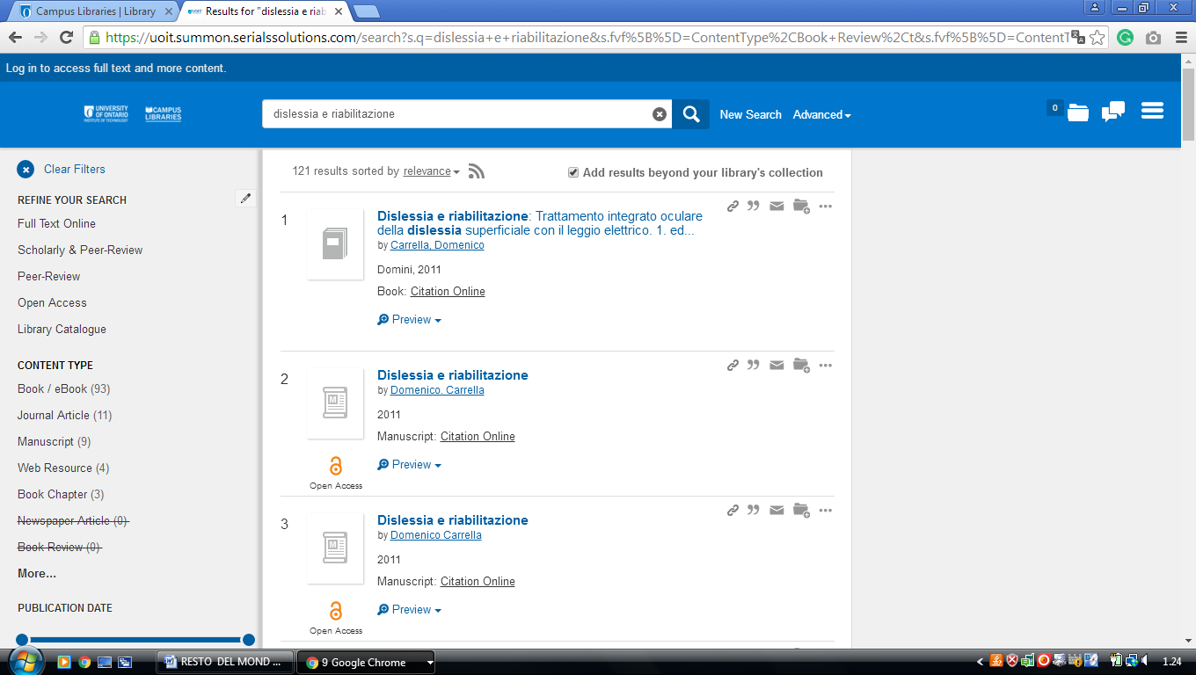

**22 QUEEN'S UNIVERSITY LIBRARY –** (Kingston, Ontario, Canada)

<http://queensu.summon.serialssolutions.com/search?s.q=dislessia+e+riabilitazione&submit=Search#!/search?ho=f&l=en&q=dislessia%20e%20riabilitazione>

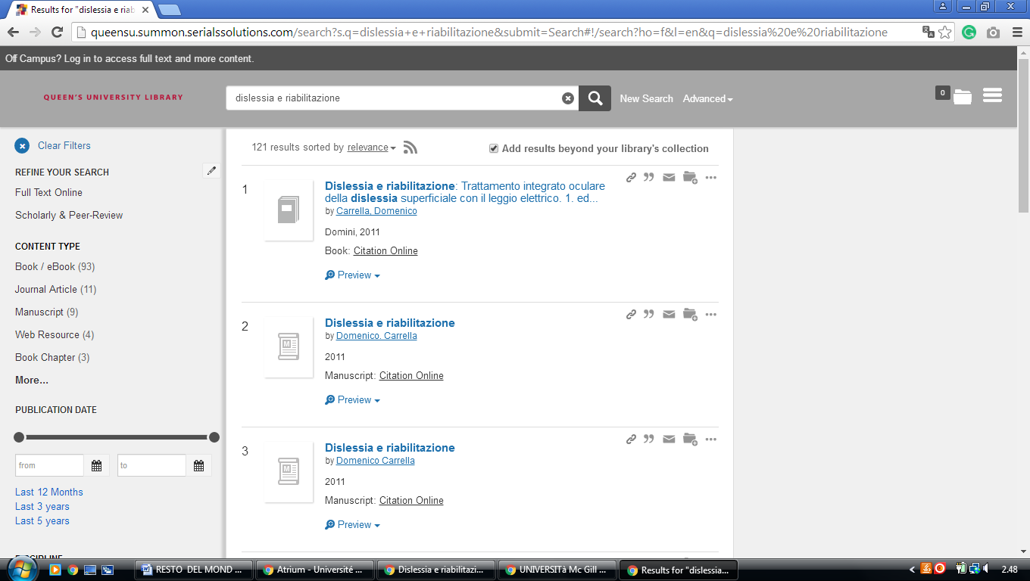

**-----------------------------------------------------------------------------------------------------------------------------**

**23  UNB LIBRARIES,** [**University Of New Brunswick**](https://www.google.it/search?rlz=1C1CHIK_itIT460IT464&q=University+Of+New+Brunswick&spell=1&sa=X&ved=0ahUKEwjRourPmZvZAhUC6KQKHWk_A2cQkeECCCQoAA) **-** ([Fredericton](https://en.wikipedia.org/wiki/Fredericton) and [Saint](https://en.wikipedia.org/wiki/Saint_John,_New_Brunswick" \o "Saint John, New Brunswick)

[John](https://en.wikipedia.org/wiki/Saint_John,_New_Brunswick" \o "Saint John, New Brunswick), [NB](https://en.wikipedia.org/wiki/New_Brunswick), [Canada](https://en.wikipedia.org/wiki/Canada))

<https://unb.worldcat.org/title/dislessia-e-riabilitazione-trattamento-integrato-oculare-della-dislessia-superficiale-con-il-leggio-elettrico/oclc/878784487&referer=brief_results>

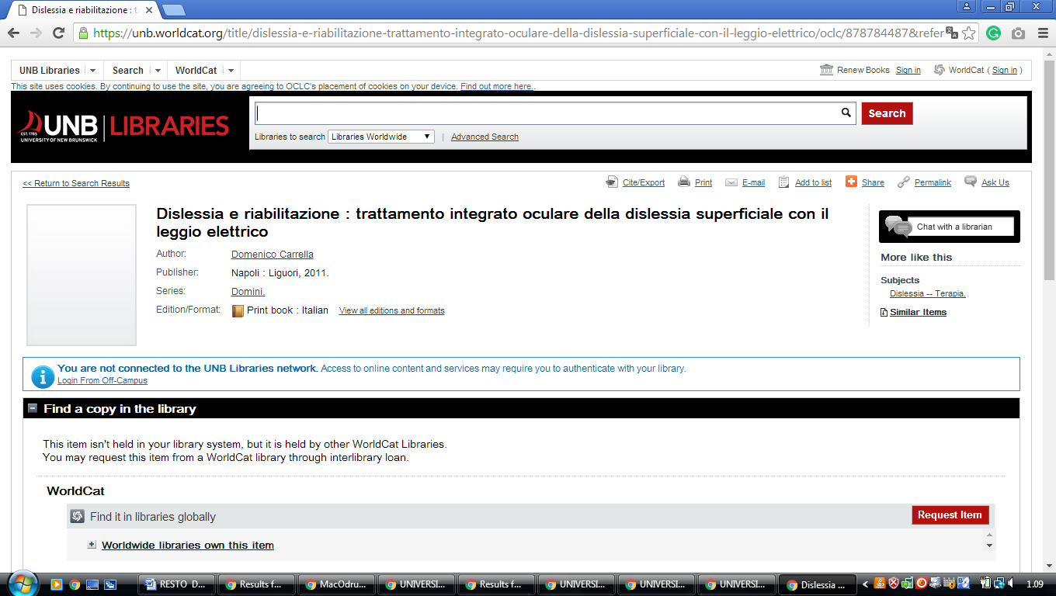

### 24 [LIBRARIES - UNIVERSITY OF VICTORIA - UVIC](https://www.uvic.ca/library/) – ([Columbia Britannica](https://it.wikipedia.org/wiki/Columbia_Britannica)

### [Canada](https://en.wikipedia.org/wiki/Canada))

<http://uvic.summon.serialssolutions.com/#!/search?ho=f&l=en&q=dislessia%20e%20riabilitazione>

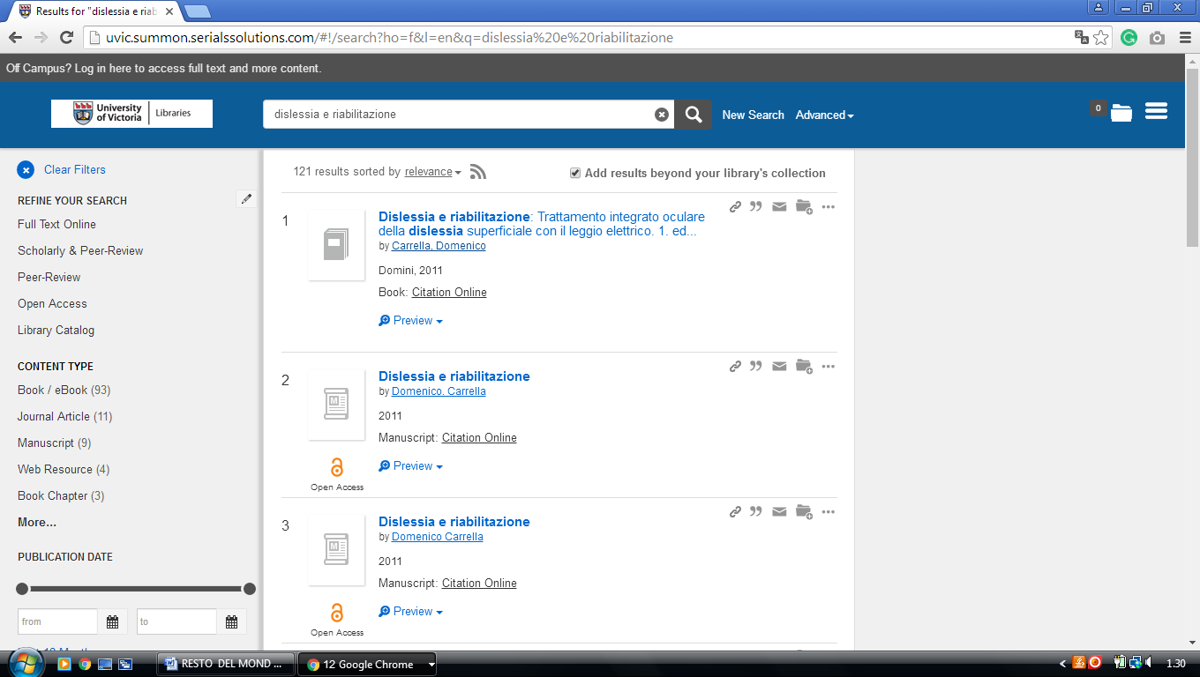

**25 UNIVERSITY OF WESTERN ONTARIO LIBRARY – (**Richmond St, London, Canada)

<https://uwo.summon.serialssolutions.com/search?s.q=dislessia+e+riabilitazione&s.cmd=addFacetValueFilters%28ContentType%2CNewspaper+Article%3At%29&spellcheck=true&keep_r=true#!/search?ho=f&fvf=ContentType,Newspaper%20Article,t&l=en-UK&q=dislessia%20e%20riabilitazione>

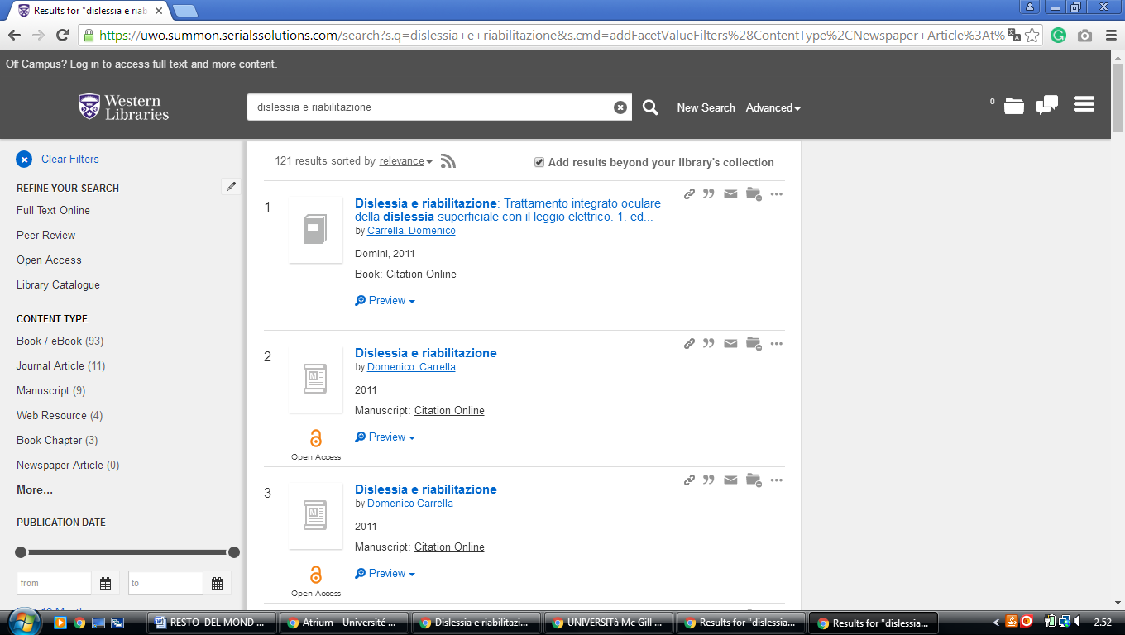

**26 KINGS UNIVERSITY COLLEGE LIBRARY** - ([London](https://en.wikipedia.org/wiki/London,_Ontario), [ON](https://en.wikipedia.org/wiki/Ontario), [Canada](https://en.wikipedia.org/wiki/Canada))

<https://uwo.summon.serialssolutions.com/search?s.q=dislessia+e+riabilitazione&s.cmd=addFacetValueFilters%28ContentType%2CNewspaper+Article%3At%29&spellcheck=true#!/search?ho=f&fvf=ContentType,Newspaper%20Article,t&l=en-UK&q=dislessia%20e%20riabilitazione>

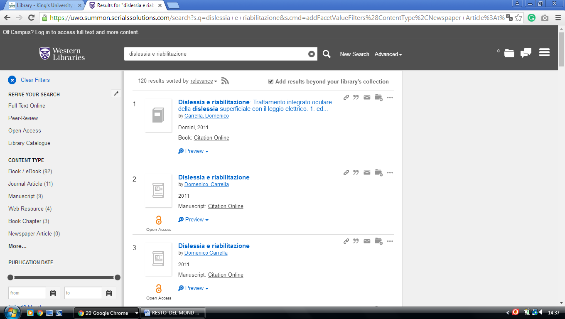

**27**  [**UNIVERSITY OF WINNIPEG LIBRARY**](http://library.uwinnipeg.ca/)  **- (**[Winnipeg](https://en.wikipedia.org/wiki/Winnipeg), [Manitoba](https://en.wikipedia.org/wiki/Manitoba), Canada)

<https://uwinnipeg.on.worldcat.org/external-search?queryString=dislessia+e+riabilitazione>

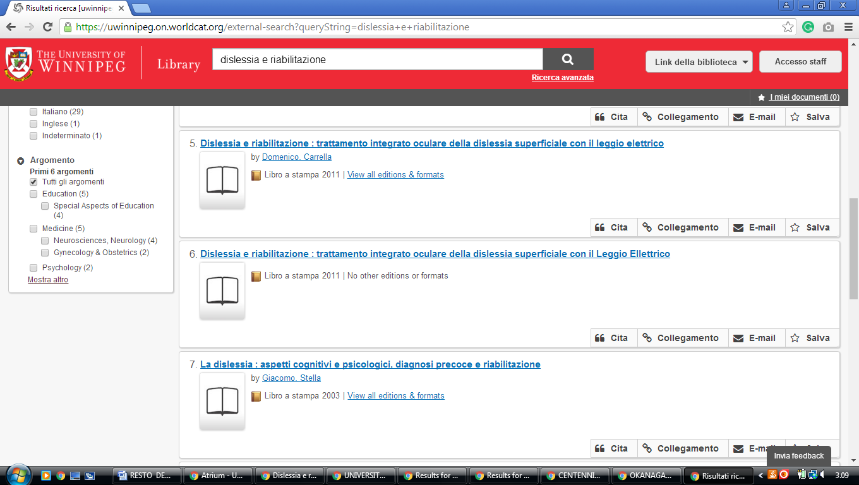

**28**  [**UNIVERSITY OF MANITOBA LIBRARIES**](http://www.umanitoba.ca/libraries/) – (Winnipeg, Manitoba, Canada)

<https://www.google.it/search?q=MOHAMMED+VI+LIBRARY&rlz=1C1CHIK_itIT460IT464&oq=MOHAMMED+VI+LIBRARY&aqs=chrome..69i57.609740j0j7&sourceid=chrome&ie=UTF-8>

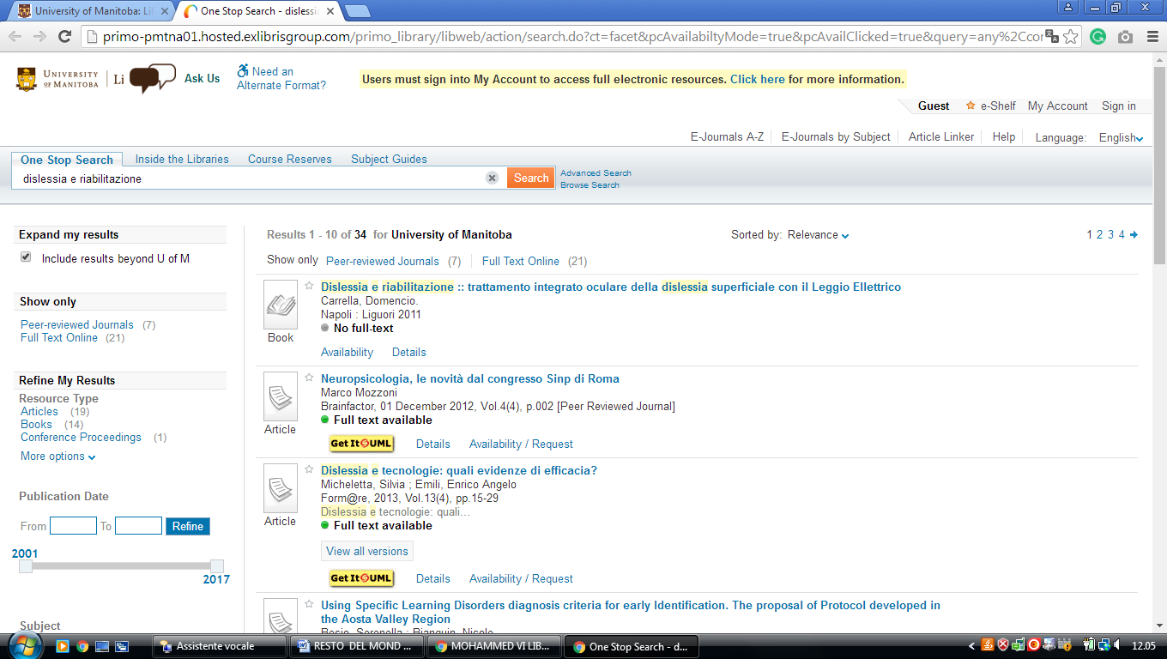

**29 LIBRARY** [**UNIVERSITY OF NEW BRUNSWICK**](http://www.lib.unb.ca/) **–** (Fredericton, Canada)

<https://unb.on.worldcat.org/search?sortKey=&databaseList=2375%2C2572%2C3384%2C1931%2C2668%2C1953%2C1875%2C2623%2C1697%2C3336%2C2268%2C2587%2C3313%2C2267%2C1672%2C3036%2C239%2C638%2C2507%2C1834%2C2221%2C2264%2C2263%2C2262%2C1271%2C2261%2C2260%2C2281%2C1842%2C1941%2C2237%2C2259%2C2897%2C2236%2C2233%2C2277%2C1708&queryString=dislessia+e+riabilitazione&changedFacet=scope&scope=&format=all&database=all&author=all&year=all&yearFrom=&yearTo=&language=all#/oclc/941217209>

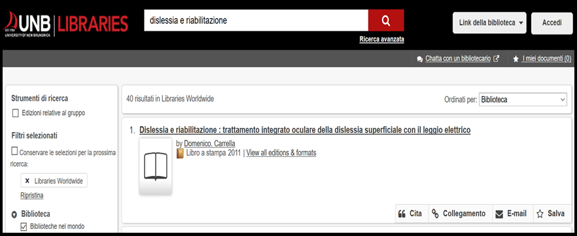

**30**  [**VAUGHAN MEMORIAL LIBRARY**](http://library.acadiau.ca/) - (Wolfville, Nova Scotia, Canada)

<https://acadiau.on.worldcat.org/search?queryString=DISLESSIA%20E%20RIABILITAZIONE&databaseList=1875,2236,1708,1719,638,1271,1834&page=1&queryType=search#/oclc/878784487>

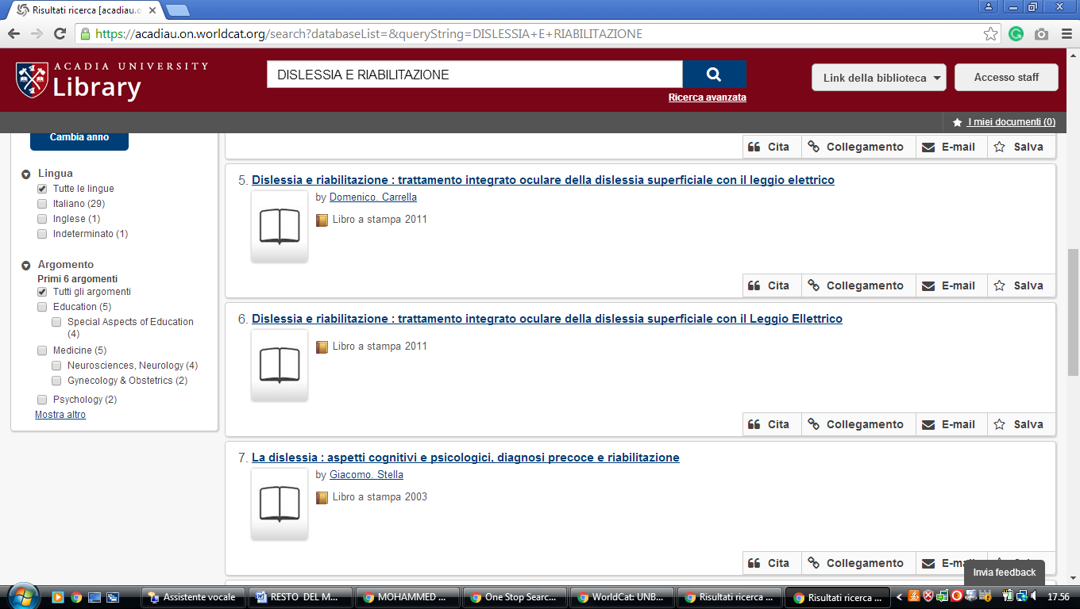

**31 NATIONAL SCIENCE LIBRARY CANADA** – (Ottawa, Ontario, Canada)

<http://fsl-bsf.summon.serialssolutions.com/en/search?q=dislessia+e+riabilitazione&ho=t&l=en&wb-srch-sub=&fvf=SourceType%2CLibrary+Catalog%2Cf%7CLibrary%2CNRC-CNRC%2Cf#!/search?ho=f&l=en&q=dislessia%20e%20riabilitazione>

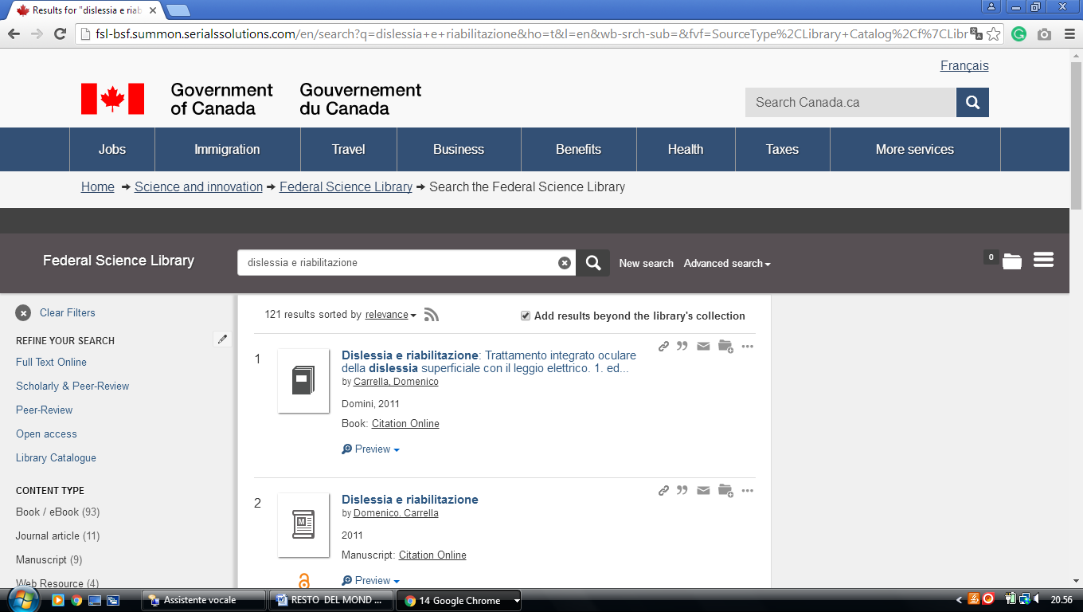

**32**  [**DOROTHY H. HOOVER LIBRARY**](http://www.ocadu.ca/library.htm) – (Toronto, Ontario, Canada)

<https://ocadu.summon.serialssolutions.com/search?q=dislessia+e+riabilitazione&submit=Search#!/search?ho=f&l=it-IT&q=dislessia%20e%20riabilitazione&submit=Search>

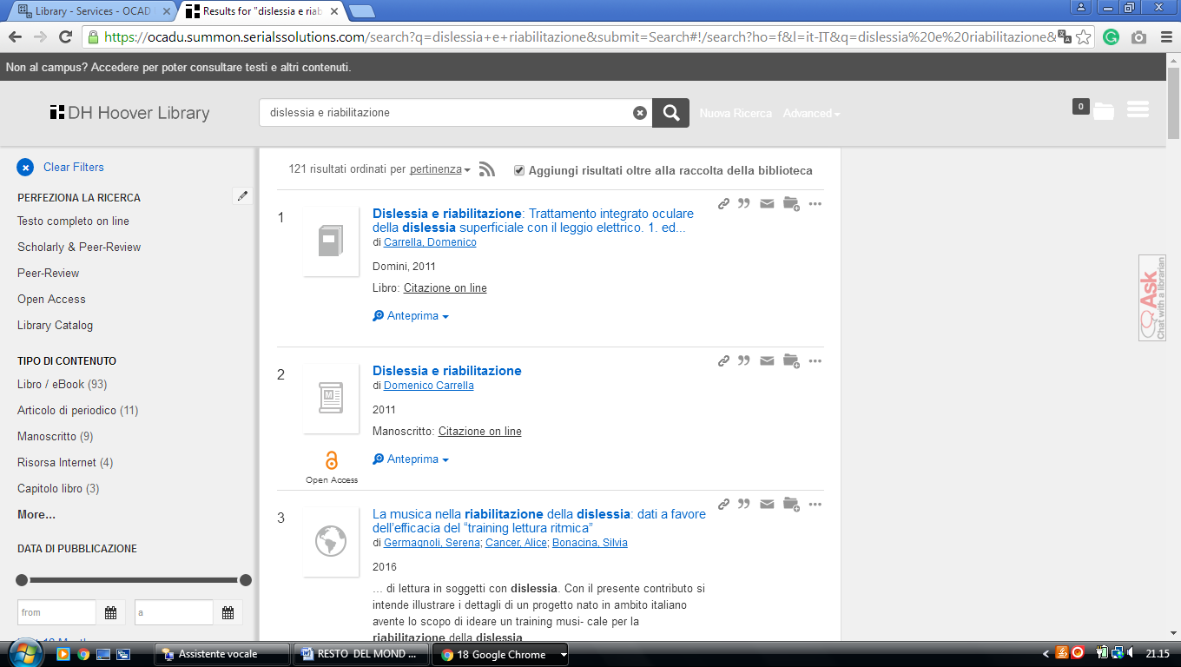

**33**  [**HUMBER LIBRARIES - HUMBER COLLEGE**](http://library.humber.ca/) **-** (Toronto, Ontario, Canada)

<http://humber.summon.serialssolutions.com/#!/search?ho=f&l=en&q=DISLESSIA%20E%20RIABILITAZIONE>

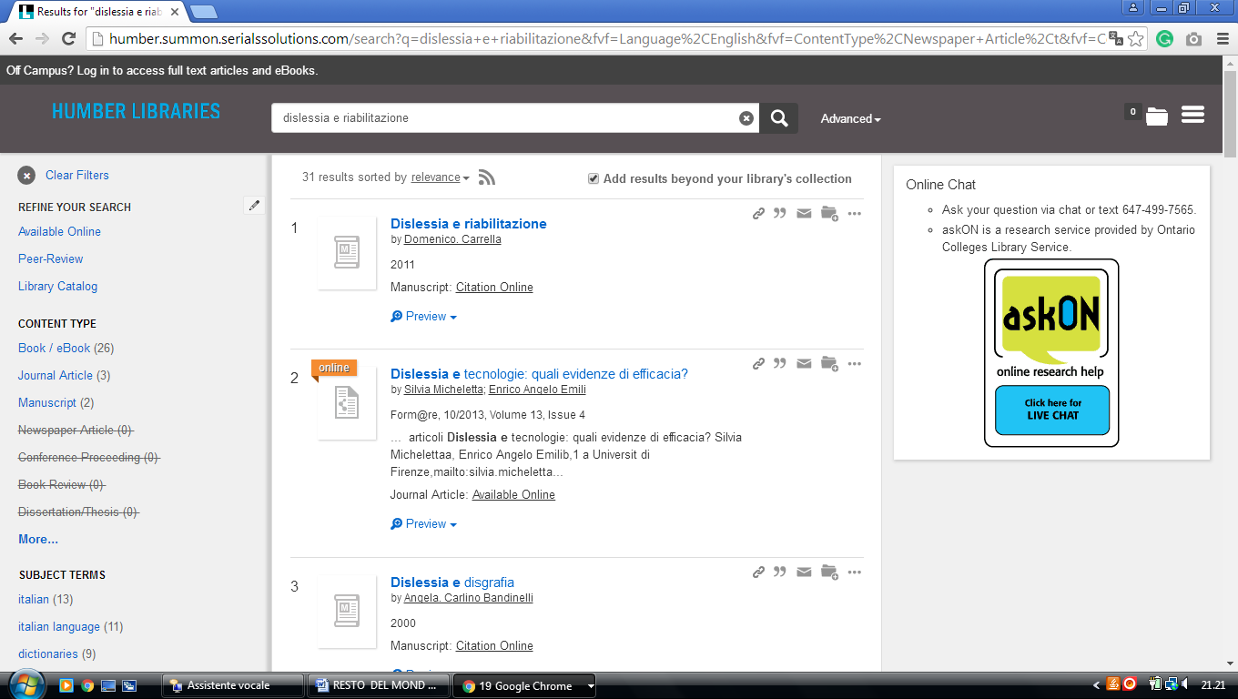

-------------------------------------------------------------------------------------------------------------------------------

**34** [**MACODRUM LIBRARY**](http://www.library.carleton.ca/)– (Ottawa, Ontario, Canada)

<https://carletonu.summon.serialssolutions.com/?q=dislessia%20e%20riabilitazione#!/search?ho=f&l=en&q=dislessia%20e%20riabilitazione>

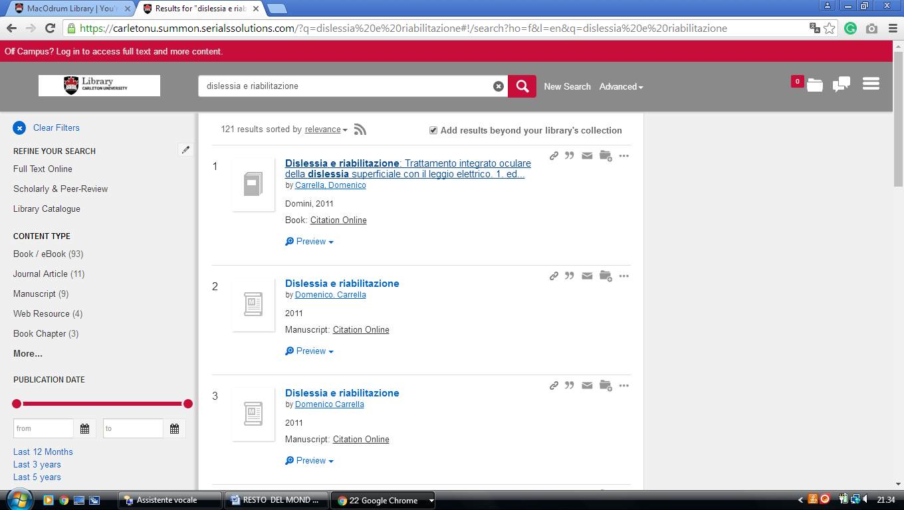

**35** [**RYERSON UNIVERSITY LIBRARY & ARCHIVES**](http://library.ryerson.ca/) – (Toronto, Ontario, Canada)

<https://ryerson.summon.serialssolutions.com/search?q=DISLESSIA+E+RIABILITAZIONE&fvf=ContentType%2CBook+Review%2Ct&spellcheck=true#!/search?ho=f&fvf=ContentType,Book%20Review,t&l=en&q=DISLESSIA%20E%20RIABILITAZIONE>

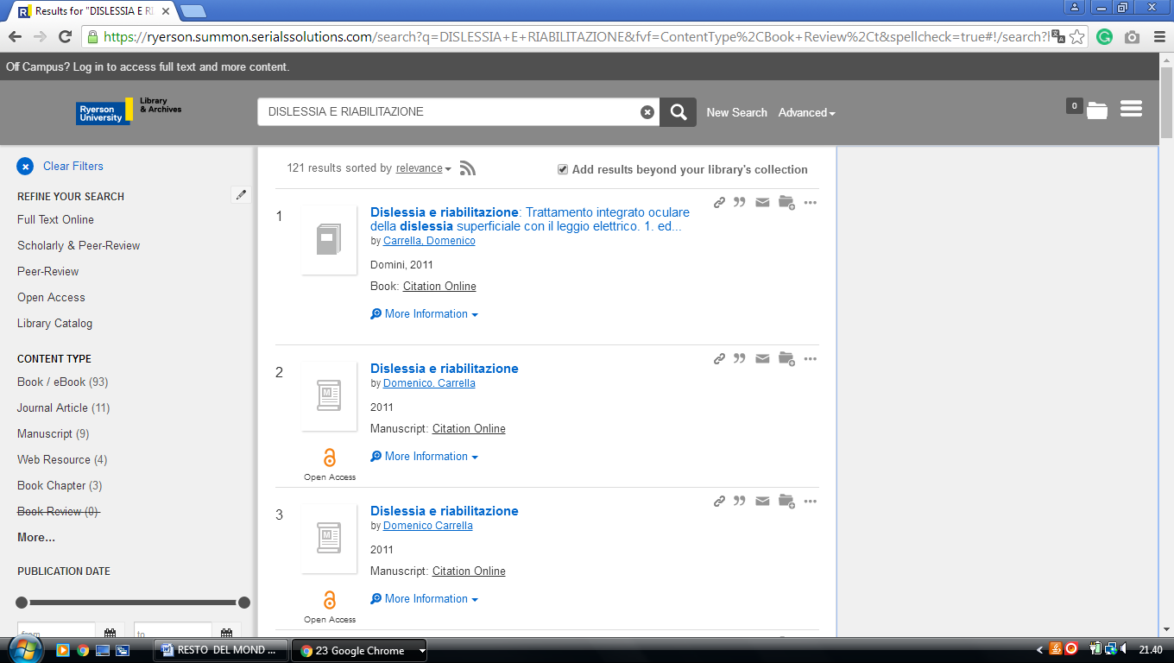

**36 LIBRARY** [**UNIVERSITY OF ONTARIO INSTITUTE**](http://www.uoit.ca/sites/library/) **OF TECHNOLOGY -(**Oshawa**,** Ontario, Canada)

<https://uoit.summon.serialssolutions.com/search?s.q=dislessia+e+riabilitazione&s.fvf%5B%5D=ContentType%2CBook+Review%2Ct&s.fvf%5B%5D=ContentType%2CNewspaper+Article%2Ct&spellcheck=true&keep_r=true#!/search?ho=f&fvf=ContentType,Book%20Review,t%7CContentType,Newspaper%20Article,t&l=en&q=dislessia%20e%20riabilitazione>

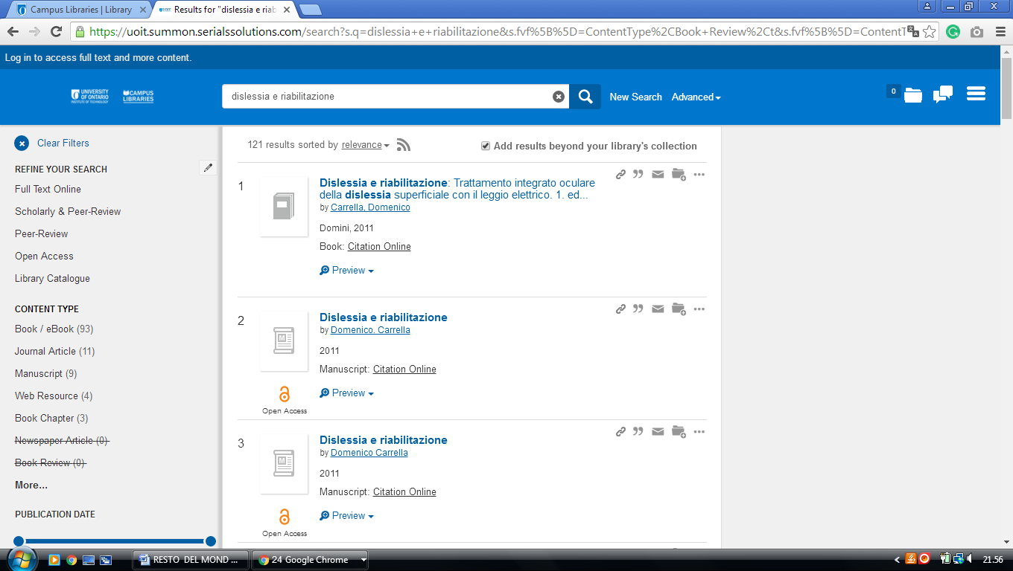

### 37 [JOHN BASSETT MEMORIAL LIBRARY - LIBRARY - BISHOP'S UNIVERSITY](http://www.ubishops.ca/MjgBg/)

(Lennoxville, Québec, Canada)

<https://ubishops.summon.serialssolutions.com/?q=dislessia+e+riabilitazione#!/search?ho=f&l=en&q=dislessia%20e%20riabilitazione>

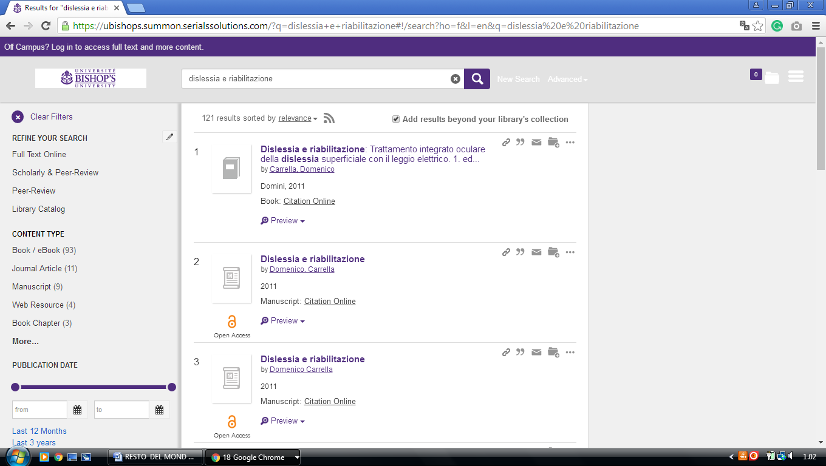

2

**38 LIBRARY** [**HEC MONTRÉAL**](http://www.hec.ca/biblio/)- (Montréal , Québec, Canada)

<http://hec.summon.serialssolutions.com/en/search?fvf=ContentType%2CBook+Review%2Ct%7CContentType%2CNewspaper+Article%2Ct&q=dislessia+e+riabilitazione#!/search?ho=f&fvf=ContentType,Book%20Review,t%7CContentType,Newspaper%20Article,t&l=en&q=dislessia%20e%20riabilitazione>

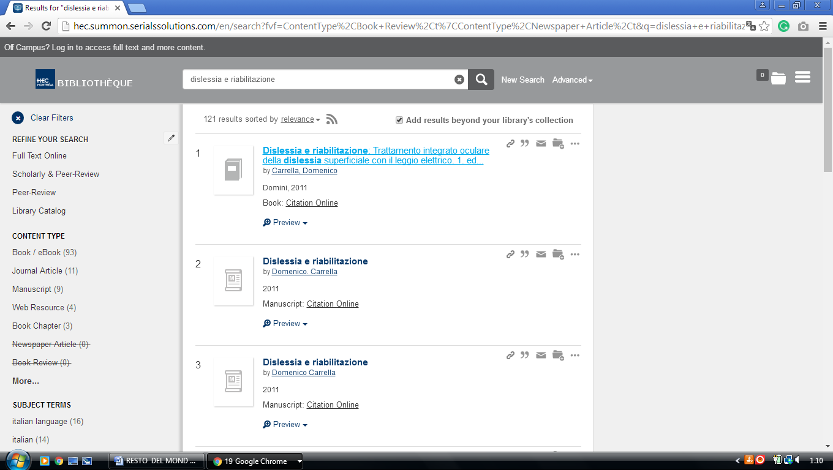

### 39 [LIBRARY - POLYTECHNIQUE MONTRÉAL](http://www.polymtl.ca/biblio/en) - (Québec, Canada)

<https://polymtl.summon.serialssolutions.com/search?q=dislessia+e+riabilitazione&x=27&y=15&fvf=ContentType%2CBook+Review%2Ct%7CContentType%2CNewspaper+Article%2Ct#!/search?ho=f&fvf=ContentType,Book%20Review,t%7CContentType,Newspaper%20Article,t&l=fr-CA&q=dislessia%20e%20riabilitazione&x=27&y=15>

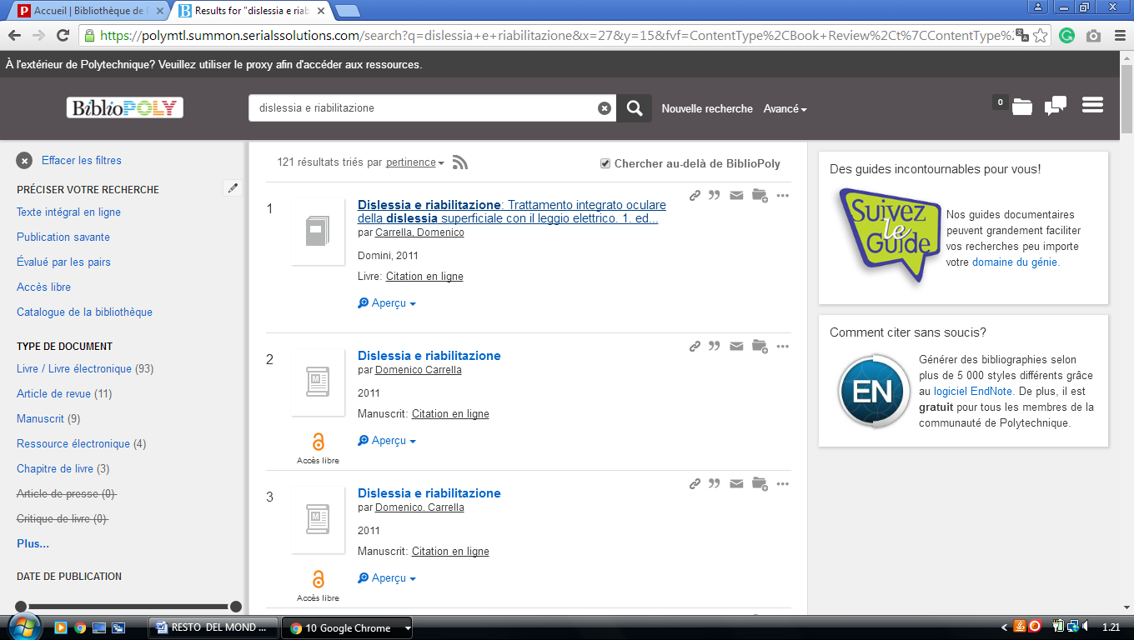

**40** [**UNIVERSITY OF MONTRÉAL LIBRARY**](http://www.bib.umontreal.ca/) **–** (Montréal, Québec, Canada)

<http://atrium.umontreal.ca/primo-explore/search?query=any,contains,DISLESSIA%20E%20RIABILITAZIONE&tab=articles&search_scope=Articles_seulement&vid=UM&lang=fr_FR&offset=0&sortby=rank&pcAvailability=true>

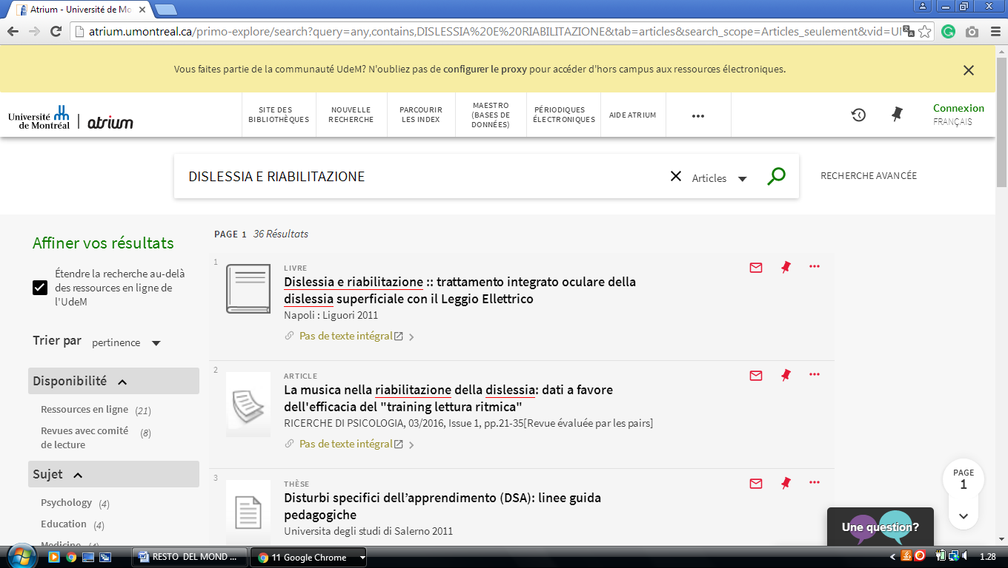

### 41 [HEALTH SCIENCES LIBRARY MCMASTER UNIVERSITY](https://hsl.mcmaster.ca/) – (Ontario Canada)

<http://mcmasteruniversity.worldcat.org/search?q=dislessia%20e%20riabilitazione>

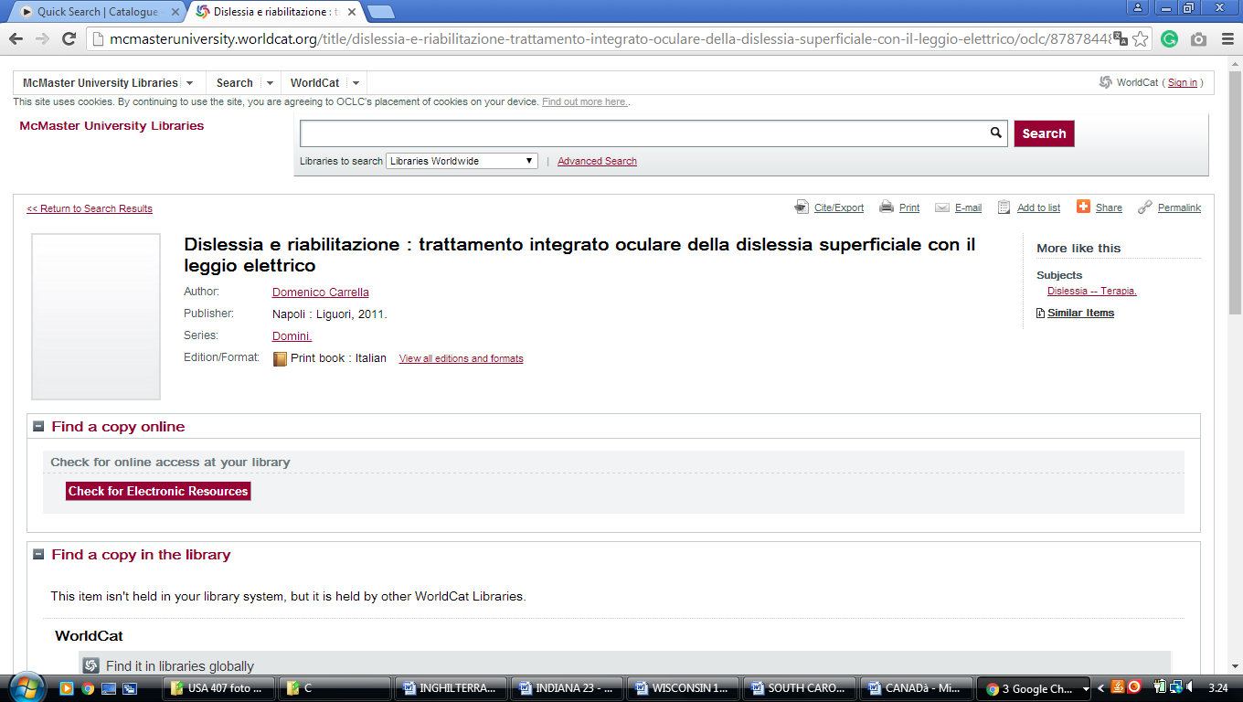

### 42 [BIBLIOTHÈQUE HEC MONTRÉAL](http://www.hec.ca/biblio/) – (Montreal, Canada)

<http://hec.summon.serialssolutions.com/?fvf=ContentType%2CBook+Review%2Ct%7CContentType%2CNewspaper+Article%2Ct&q=dislessia+e+riabilitazione#!/search?ho=f&fvf=ContentType,Book%20Review,t%7CContentType,Newspaper%20Article,t&l=fr-CA&q=dislessia%20e%20riabilitazione>

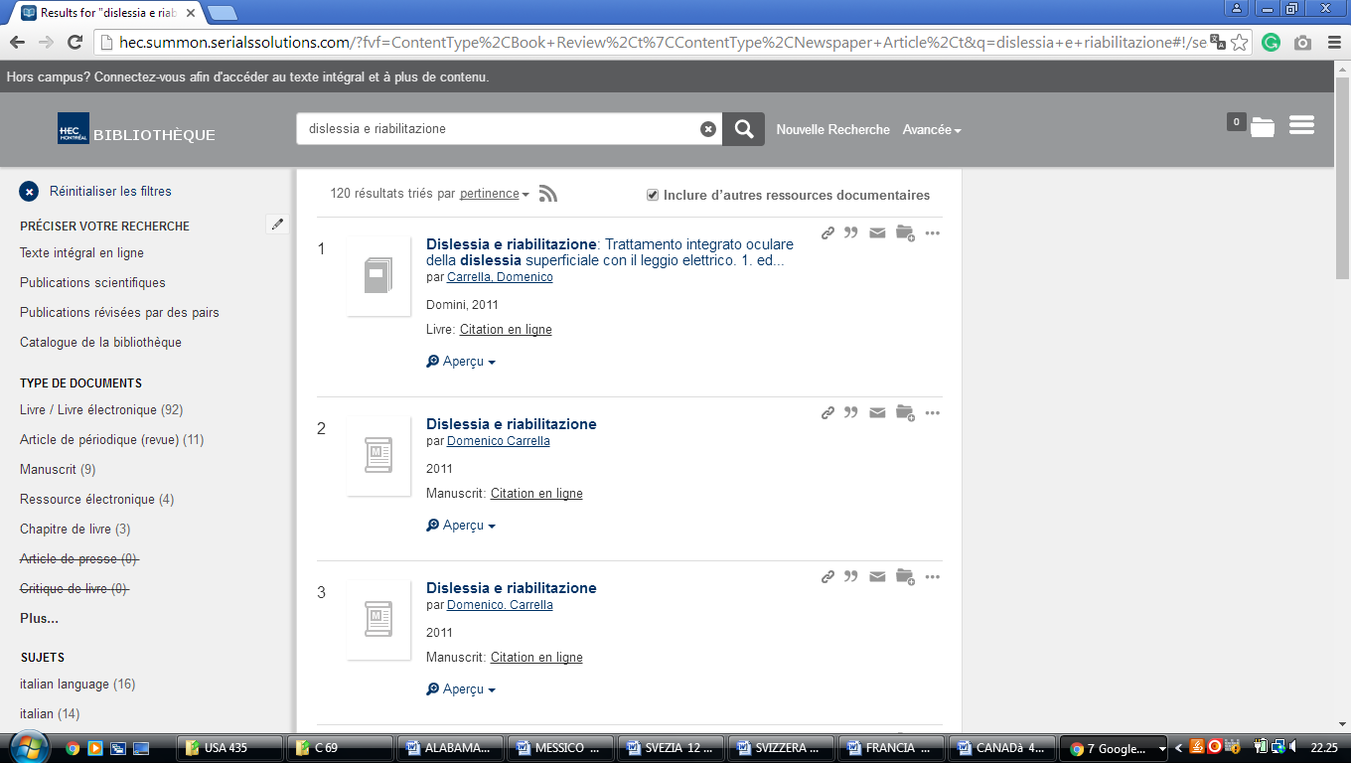

[KPU Library | KPU.ca - Kwantlen Polytechnic University](https://www.google.com/url?sa=t&rct=j&q=&esrc=s&source=web&cd=2&cad=rja&uact=8&ved=2ahUKEwjq_e3JsLToAhVxxIsKHfpJBYoQFjABegQIBhAB&url=http%3A%2F%2Fwww.kpu.ca%2Flibrary&usg=AOvVaw1ZdWmea5hHDLGk9Kz02PJ2)

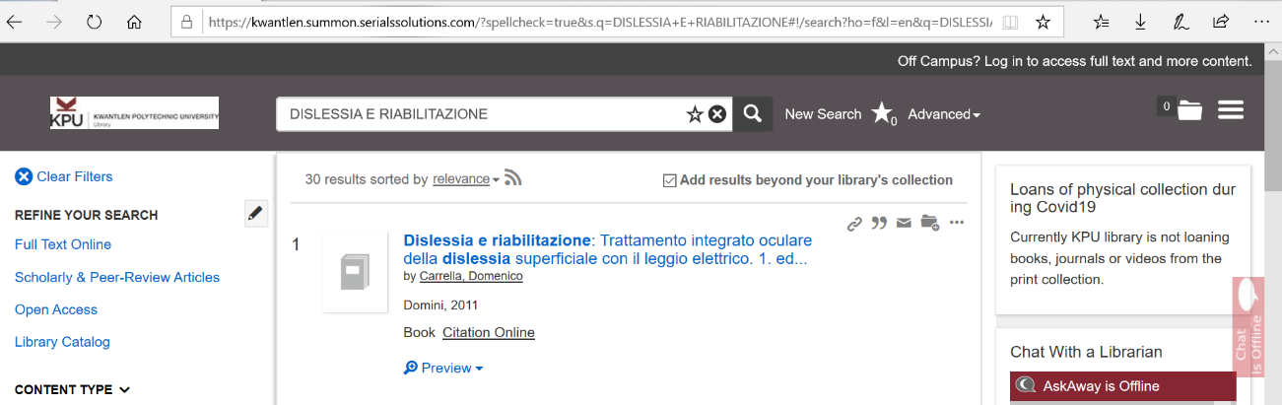

[**VANCOUVER ISLAND UNIVERSITY**](https://www2.viu.ca/library/)

[**VANCOUVER ISLAND UNIVERSITY**](https://www2.viu.ca/library/)

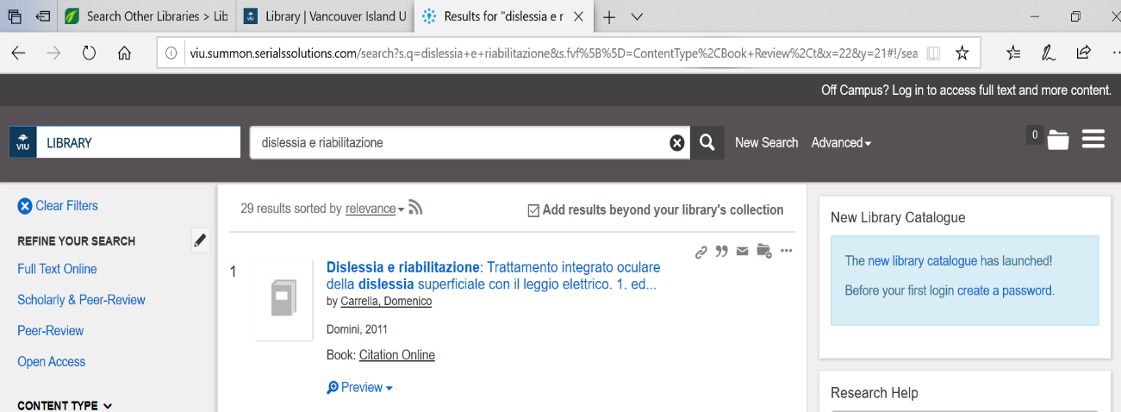viu.summon.serialssolutions.com/