**AUBG LIBRARY AMERICAN UNIVERSITY,** [**Blagoevgrad**](https://en.wikipedia.org/wiki/Blagoevgrad)**, BULGARIA**

[Panitza Library | AUBG - American University in Bulgaria](https://www.google.com/url?sa=t&rct=j&q=&esrc=s&source=web&cd=1&cad=rja&uact=8&ved=2ahUKEwjPuJ6d-MzoAhVCC-wKHRg5DIEQFjAAegQIARAC&url=https%3A%2F%2Fwww.aubg.edu%2Flibrary&usg=AOvVaw04V6svRqjB5XguoOcr32QT)

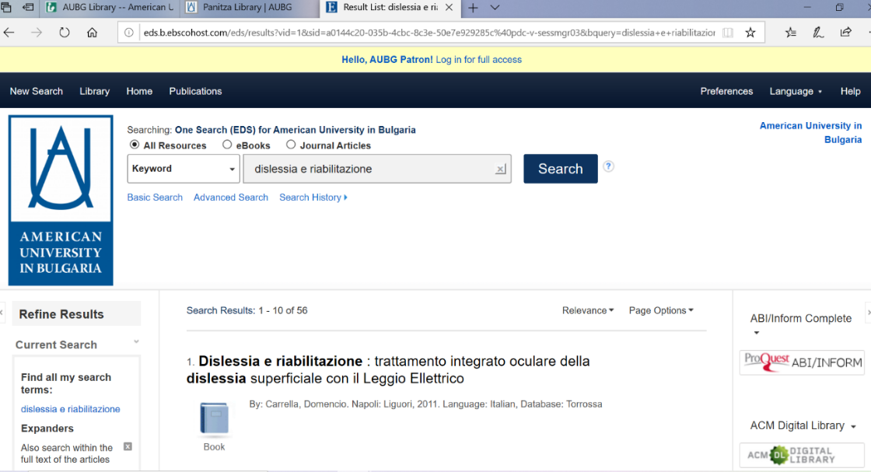

[**Sofia University Library St. Kl. Ohridski …**](https://librarytechnology.org/library/196364)

[**Достъпът е активен през акаунта на Ebsco**](http://search.ebscohost.com/Community.aspx?authtype=ip&stsug=Aj_P5sPDV-hb3CzMKzhi1w0NGwf5ecBvSeOl6OvmKRFBqrGRpGFCqD005NTO9HkdJWZfwI6tvFf6fgfdFF1wgD9S5fy0RvEXdLoiezg81mRGBmMWP6nwbm6SKH_Ctmk3DJA-D3TUFY2HHRnvOZLQQ07I8vDpVWD9UR2he-qcI-h8K40&IsAdminMobile=N&encid=22D731263C7635573716352632953C77348378C376C374C378C379C371C376C33013&selectServicesToken=Az_a41k_1r5BUw5Jnra3XlkGIvusb4G-lW1gq7LEoVZhSH_W9fygqw1FXdG60aUEoWeyngNwC0lTaPoQTwJ4JULal1D6wQJ1bzGGBZ8w40unMLyHfx1jjX5ZLIxHAC5VfGA17oFKJ8Y2yaJwNDaFhciOUSR92RjuVNOene6ia5MEBHyX243x_I-ilr4zK6Zy4jeDYyXmpRUhBVgLjjCCVlUSZCjosvEzWoRcN4kEPWuIjmFGgiHtQnPQfe3jPCqGcpciBhCXdmYBGcFxhQzZYmi3fK8vIQMqcaZ6LJfAEUrQfxyWuO1moACRm18WZEhgfS4Vbvy2MGm5zFBDsNrhyqK72lmjswrVWhzOKYjX3PotIMlR)

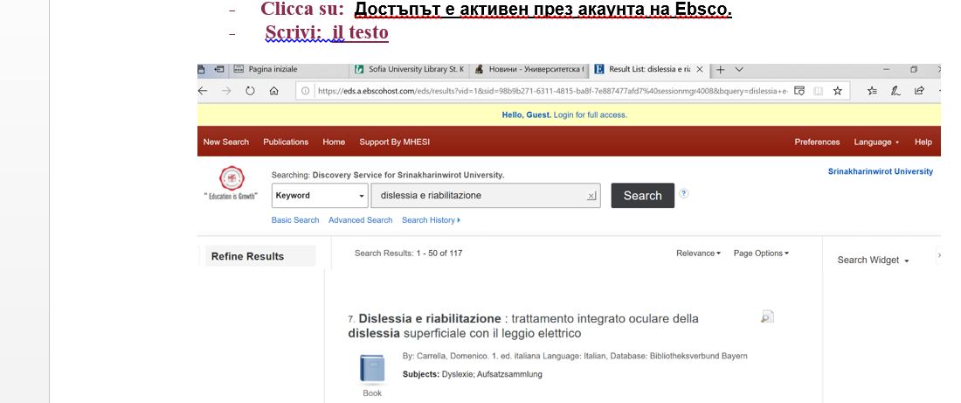

[Blagoevgrad](https://en.wikipedia.org/wiki/Blagoevgrad)**, AUBG Library American University -- Bulgaria**

Panitza Library

