# 1 PORTAL DE BUSCA INTEGRDA - (Sistema Integrado De Bibliotecas Da Universidade, De São Paulo, Brasile)

# <http://www.buscaintegrada.usp.br/primo_library/libweb/action/search.do?dscnt=1&scp.scps=scope%3A%28%22USP%22%29%2Cprimo_central_multiple_fe&frbg=&tab=default_tab&dstmp=1518654629683&srt=rank&ct=search&mode=Basic&dum=true&indx=1&tb=t&vl(freeText0)=DISLESSIA+E+RIABILITAZIONE&fn=search&vid=USP&fromLogin=true>

[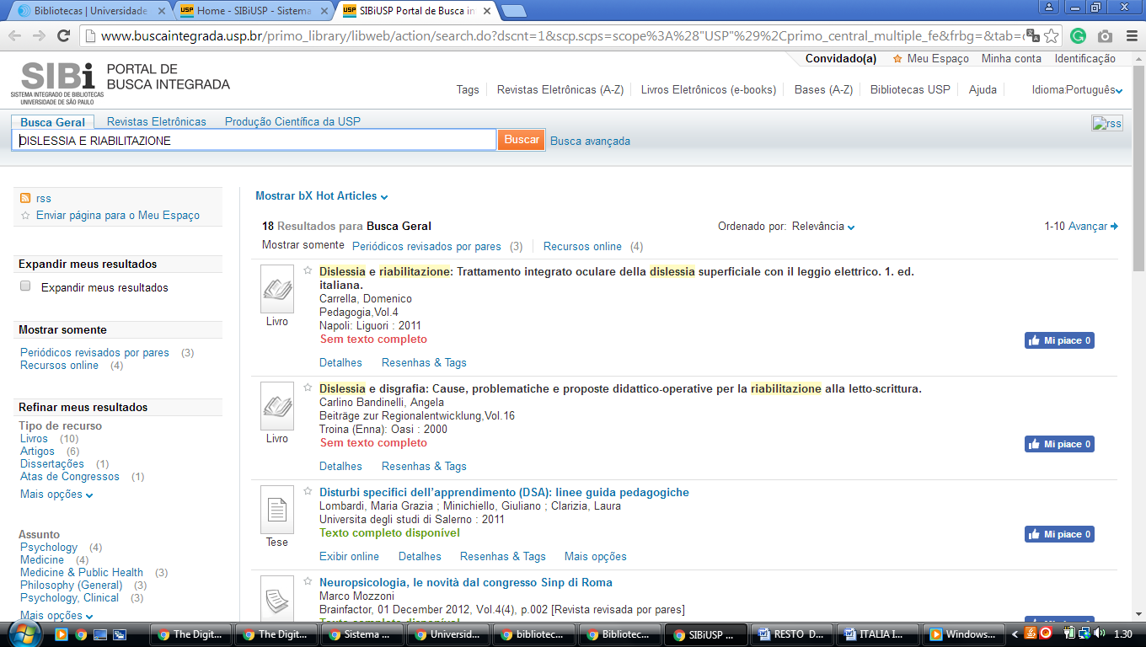](http://www.buscaintegrada.usp.br/primo_library/libweb/action/search.do?dscnt=1&scp.scps=scope%3A%28%22USP%22%29%2Cprimo_central_multiple_fe&frbg=&tab=default_tab&dstmp=1518654629683&srt=rank&ct=search&mode=Basic&dum=true&indx=1&tb=t&vl(freeText0)=DISLESSIA+E+RIABILITAZIONE&fn=search&vid=USP&fromLogin=true)

# 2 [Universidade Federal de Paran´](http://www.portal.ufpr.br/)

<http://eds.a.ebscohost.com/eds/results?vid=3&sid=3b22eace-6174-4e25-b096-3384e8a27f07%40sessionmgr4007&bquery=dislessia+e+riabilitazione&bdata=Jmxhbmc9cHQtYnImdHlwZT0wJnNlYXJjaE1vZGU9QW5kJnNpdGU9ZWRzLWxpdmU%3d>

