**UNIVERSITY LIBRARY, Yangon, BIRMANIA**

[Library | University of Yangon](https://www.google.com/url?sa=t&rct=j&q=&esrc=s&source=web&cd=5&cad=rja&uact=8&ved=2ahUKEwjjkaPK-MzoAhXBy6QKHYZqDrQQFjAEegQIAhAB&url=https%3A%2F%2Fwww.uy.edu.mm%2Fe-library%2F&usg=AOvVaw1Im_ckzBYZQR5TbQL9awZF&cshid=1585940535291680)

[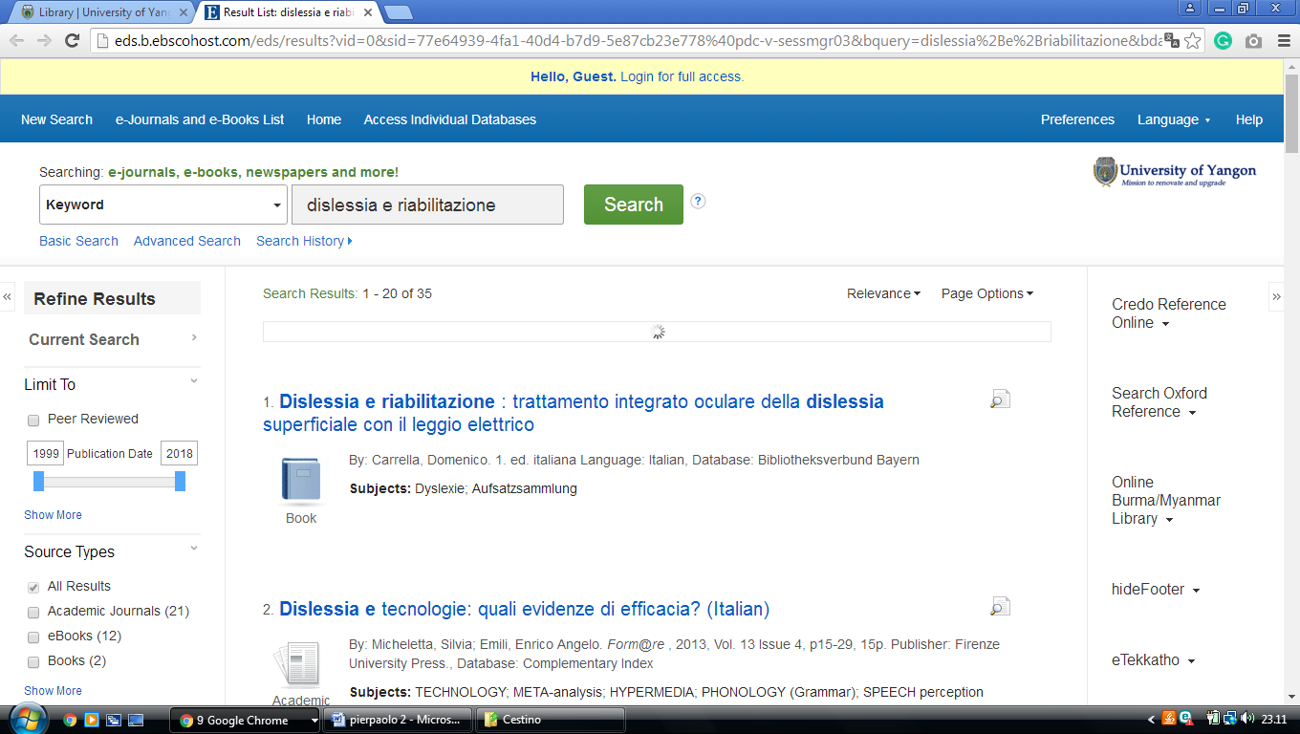](https://www.google.com/url?sa=t&rct=j&q=&esrc=s&source=web&cd=5&cad=rja&uact=8&ved=2ahUKEwjjkaPK-MzoAhXBy6QKHYZqDrQQFjAEegQIAhAB&url=https%3A%2F%2Fwww.uy.edu.mm%2Fe-library%2F&usg=AOvVaw1Im_ckzBYZQR5TbQL9awZF&cshid=1585940535291680)

[University Of Yangon |](https://www.uy.edu.mm/e-library/) **[BIRMANIA](https://www.uy.edu.mm/e-library/)**

**[University Of Yangon Library](https://www.uy.edu.mm/e-library/)** [|](https://www.uy.edu.mm/e-library/)

[http://eds.b.ebscohost.com/eds/results?vid=0&sid=77e64939-4fa1-40d4-b7d9-5e87cb23e778%40pdc-v-sessmgr03&bquery=dislessia%2Be%2Briabilitazione&bdata=JnR5cGU9MCZzZWFyY2hNb2RlPUFuZCZzaXRlPWVkcy1saXZl](https://www.uy.edu.mm/e-library/)

[](https://www.uy.edu.mm/e-library/)