**1**  [**UNIVERSITY OF ADELAIDE LIBRARY**](http://www.adelaide.edu.au/library/) - (Adelaide, Australia)

<http://adelaide.hosted.exlibrisgroup.com/primo_library/libweb/action/search.do?ct=facet&pcAvailabiltyMode=true&pcAvailClicked=true&vl(31766897UI0)=any&query=any%2Ccontains%2Cdislessia%20e%20riabilitazione&indx=1&fn=search&search_scope=Everything&dscnt=0&scp.scps=scope%3A(61ADELAIDEU)%2Cscope%3A(DSpace)%2Cprimo_central_multiple_fe&vl(1UIStartWith0)=contains&vid=SUA&ct=search&institution=61ADELAIDEU&tab=default_tab&vl(freeText0)=dislessia%20e%20riabilitazione&dstmp=1518081412485&fromDL>

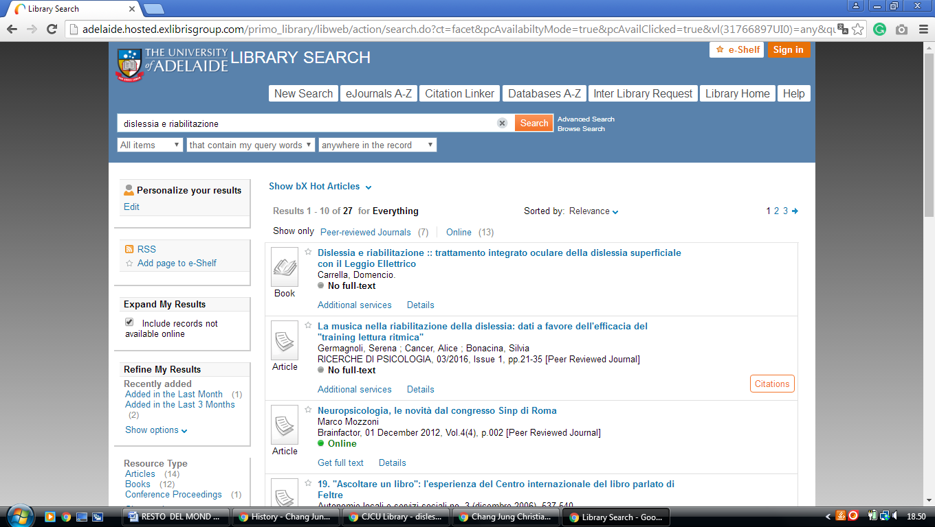

**2** [**AUSTRALIAN NATIONAL UNIVERSITY**](http://anulib.anu.edu.au/)**LIBRARY** - (CollectionCanberra, Australia)

[https://anu.summon.serialssolutions.com/search?q=dislessia+e+riabilitazione&button3=GO#!/search?ho=f&l=en&q=dislessia%20e%20riabilitazione&button3=GO](https://anu.summon.serialssolutions.com/search?q=dislessia+e+riabilitazione&button3=GO%23!/search?ho=f&l=en&q=dislessia%20e%20riabilitazione&button3=GO)

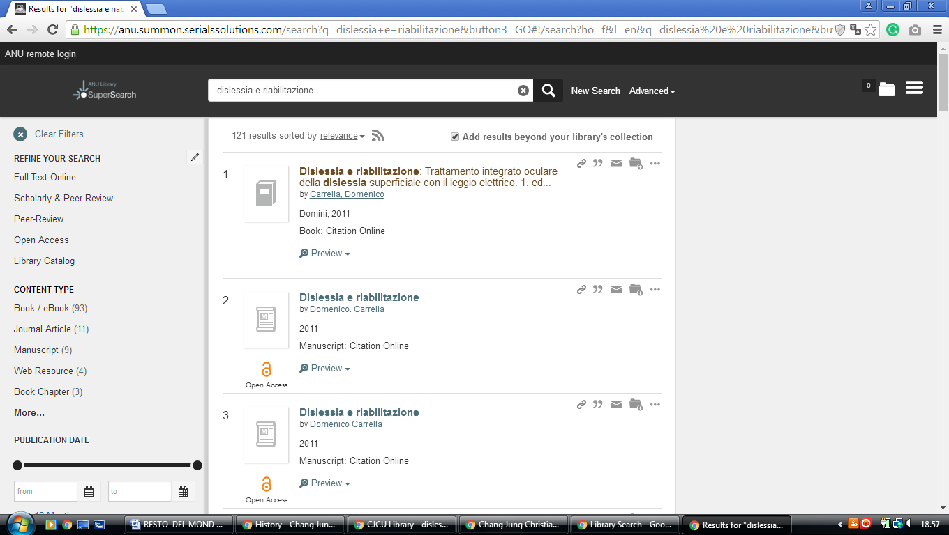

### 3 [CUNNINGHAM LIBRARY - AUSTRALIAN COUNCIL FOR EDUCATIONAL RESEARCH](https://www.acer.org/library) – (Melbourne, Australia)

<http://eds.a.ebscohost.com/eds/results?vid=0&sid=c759e645-5204-44a8-8bed-e079f83d5ac7%40sessionmgr4006&bquery=dislessia+e+riabilitazione&bdata=JnR5cGU9MCZzaXRlPWVkcy1saXZl>

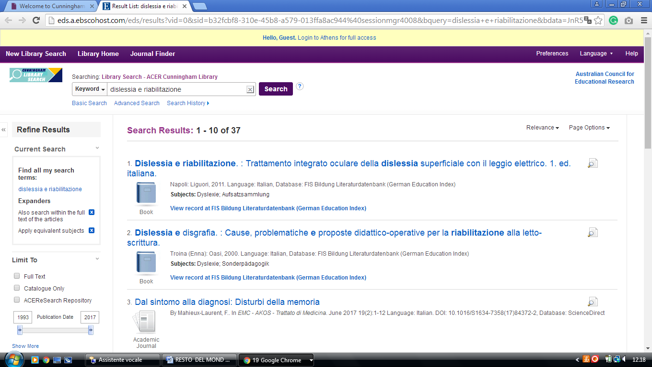

**4 ACT HEALTH LIBRARY -**  (Australian Capital Territory, Canberra,Australia)

<https://canberra-hospital-primo.hosted.exlibrisgroup.com/primo-explore/search?institution=61CHO&vid=61CHO&query=any,contains,dislessia%20e%20riabilitazione&displayMode=full&mode=Basic&bulkSize=10&highlight=true&dum=true&displayField=all&pcAvailabiltyMode=false&tab=default_tab&search_scope=default_scope&a2af7bb3e73de262587bd275fd56345d=&a2af7bb3e73de262587bd275fd56345d=&queryTemp=dislessia%20e%20riabilitazione&sortby=rank&pcAvailability=true>

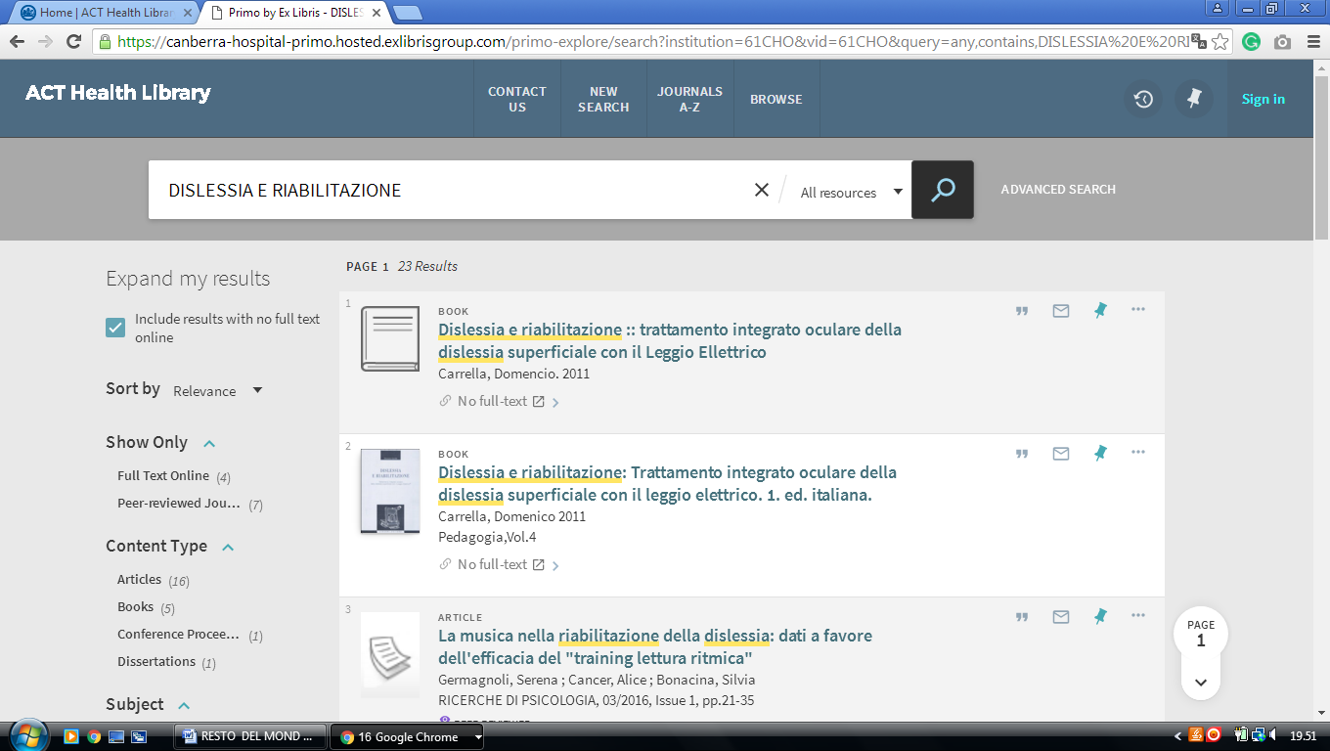

**5** [**UNIVERSITY OF CANBERRA LIBRARY**](http://www.canberra.edu.au/library/) – (Canberra, Australia)

<https://canberra.primo.exlibrisgroup.com/discovery/search?institution=61ARL_CNB&vid=61ARL_CNB:61ARL_CNB&tab=Everything&search_scope=MyInst_and_CI&mode=Basic&displayMode=full&bulkSize=10&highlight=true&dum=true&query=any,contains,dislessia%20e%20riabilitazione&displayField=all&pcAvailabiltyMode=true&sortby=rank&pcAvailability=true>

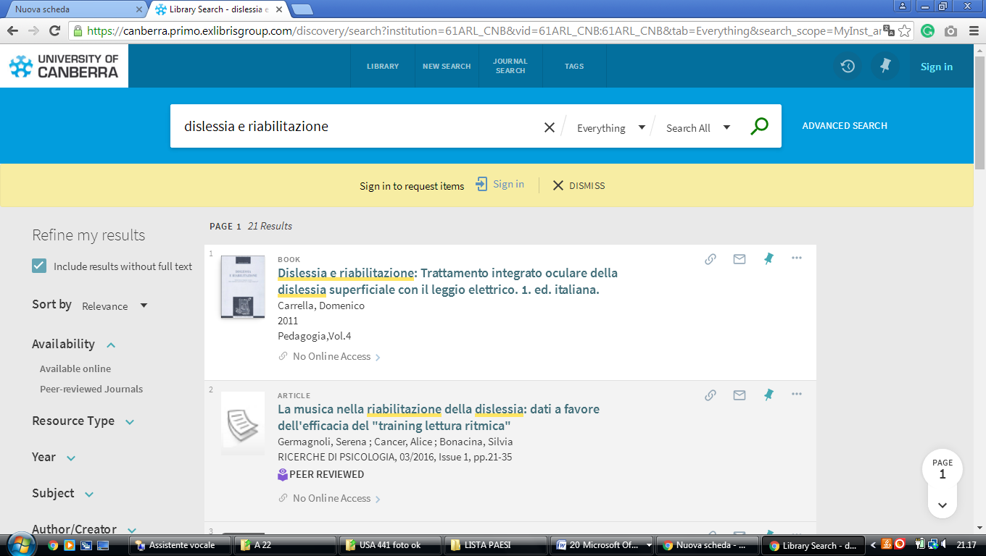

### 6 CQUNIVERSITY AUSTRALIA LIBRAY – ([Central Queensland University](https://en.wikipedia.org/wiki/Central_Queensland_University)

Australia)

<https://cqu-primo.hosted.exlibrisgroup.com/primo-explore/search?query=any,contains,dislessia%20e%20riabilitazione&tab=61cqu_library&search_scope=61CQU_Library&vid=61CQU&lang=en_US&offset=0&sortby=rank&pcAvailability=true>

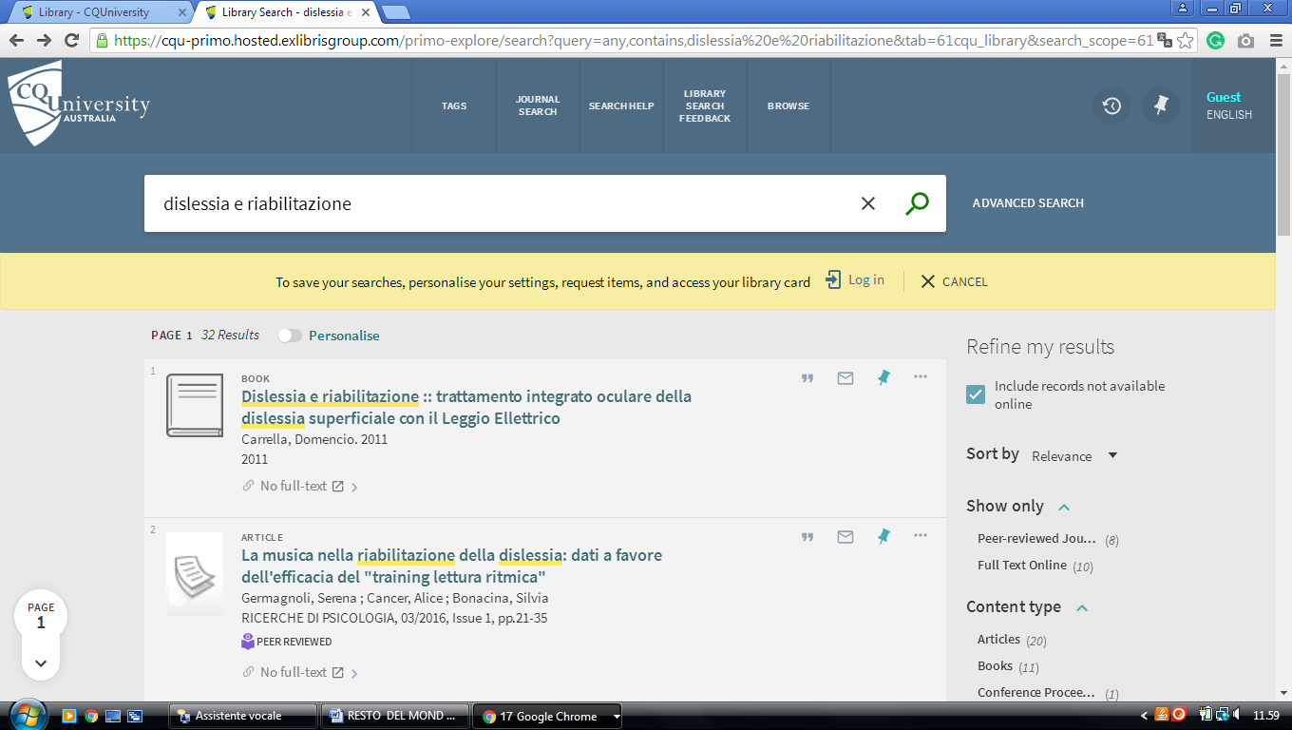

### 7 CSU LIBRARY - PRIMO SEARCH – UNILINC - ([Charles Sturt University](http://www.csu.edu.au/division/library/), Bathurst, Australia)

<http://primo.unilinc.edu.au/primo_library/libweb/action/search.do?ct=facet&pcAvailabiltyMode=true&pcAvailClicked=true&frbg=&&fn=search&indx=1&dscnt=0&vl(1UIStartWith0)=contains&scp.scps=scope%3A(DTL_CSU_UNLOCKED)%2Cscope%3A(2520)%2Cscope%3A(CSU)%2Cscope%3A(CSU_DTL_OPEN)%2Cscope%3A(CSU_EQUELLA)%2Cprimo_central_multiple_fe&vid=CSU&mode=Basic&ct=search&vl(96177725UI0)=any&srt=rank&tab=default_tab&dum=true&vl(freeText0)=DISLESSIA%20E%20RIABILITAZIONE&dstmp=1518090309684>

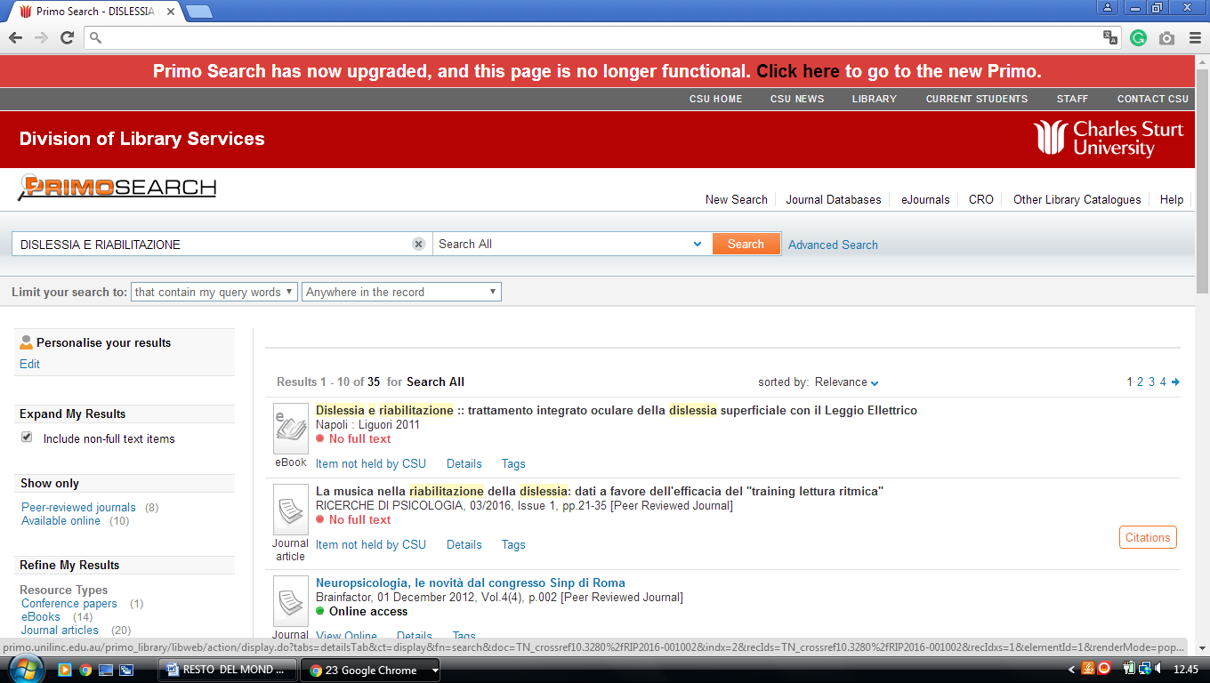

### 8 GRIFFITH.SUMMON.SERIALSSOLUTIONS.COM - ([Library Griffith University](https://www2.griffith.edu.au/library)

Brisbane, Australia)

[http://griffith.summon.serialssolutions.com/#!/search?ho=f&l=en-AU&q=dislessia%20e%20riabilitazione](http://griffith.summon.serialssolutions.com/%23!/search?ho=f&l=en-AU&q=dislessia%20e%20riabilitazione)

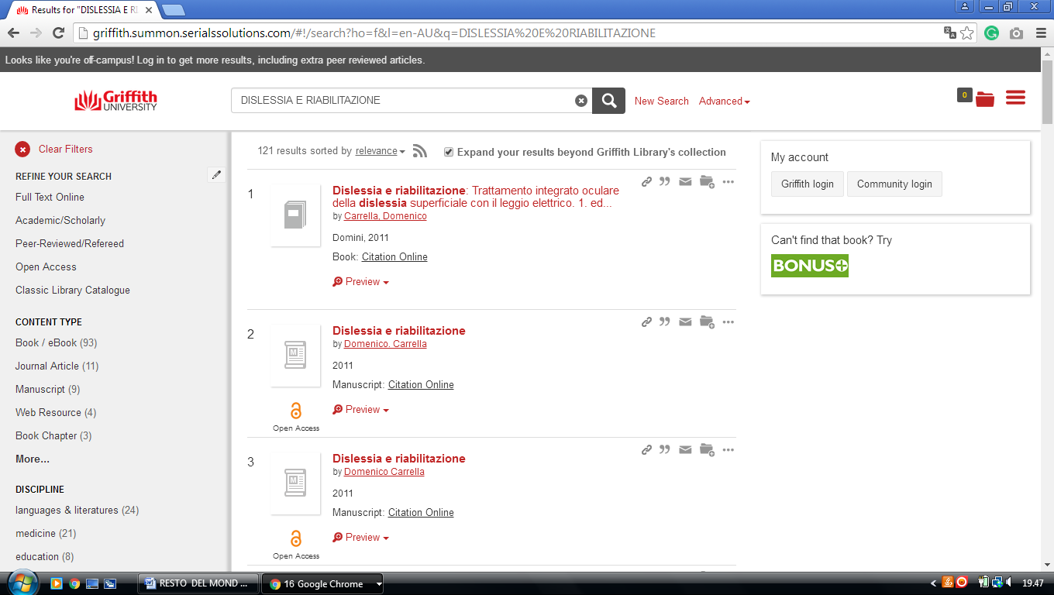

**9**  [**LIBRARY | MURDOCH UNIVERSITY**](http://library.murdoch.edu.au/) **– (**[Perth](https://en.wikipedia.org/wiki/Perth), [Western Australia](https://en.wikipedia.org/wiki/Western_Australia))

[http://murdoch.summon.serialssolutions.com/?#!/search?ho=f&l=en&q=dislessia%20e%20riabilitazione](http://murdoch.summon.serialssolutions.com/?%23!/search?ho=f&l=en&q=dislessia%20e%20riabilitazione)

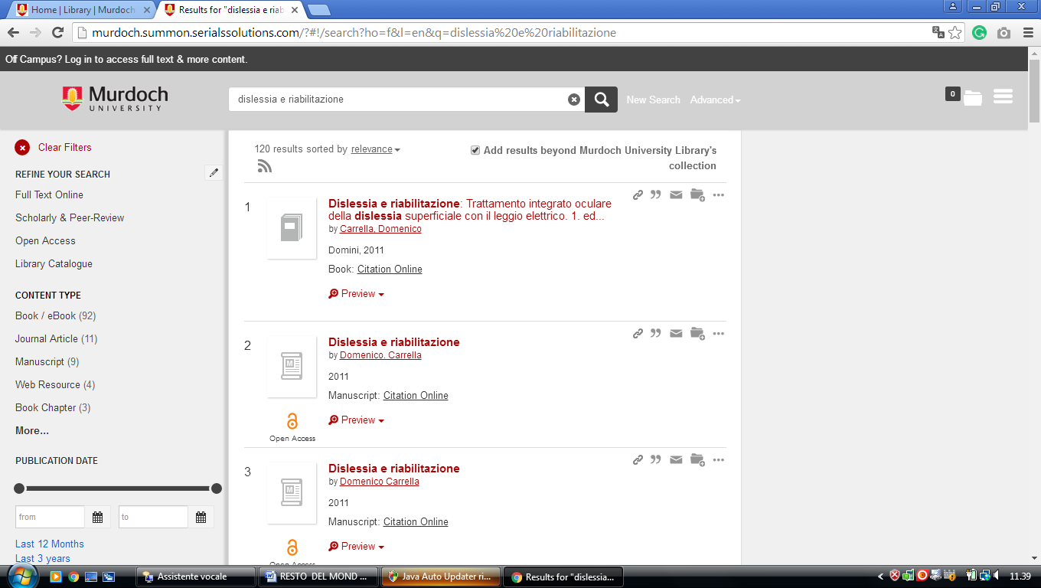

### 10 [UNIVERSITY LIBRARY AT NOTRE DAME AUSTRALIA](http://library.nd.edu.au/) - ([Fremantle](https://en.wikipedia.org/wiki/Fremantle), Australia)

[https://ndaus.summon.serialssolutions.com/?#!/search?ho=f&fvf=ContentType,Newspaper%20Article,t&l=en-AU&q=dislessia%20e%20riabilitazione](https://ndaus.summon.serialssolutions.com/?" \l "!/search?ho=f&fvf=ContentType,Newspaper%20Article,t&l=en-AU&q=dislessia%20e%20riabilitazione)

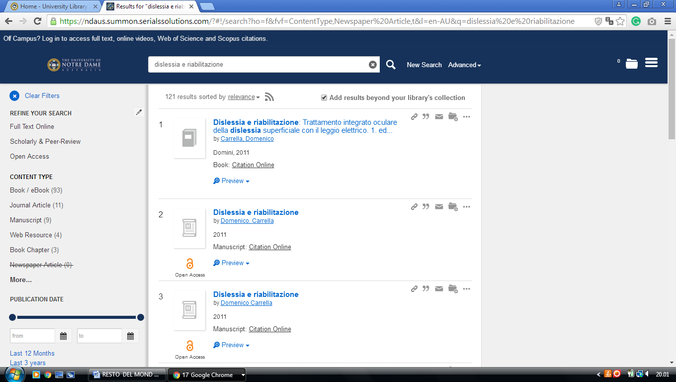

**11** [**ROYAL MELBOURNE INSTITUTE**](http://www.rmit.edu.au/library/) **OF TECHNOLOGY LIBRARY** (MELBOURNE, Australia)

[https://primo-direct-apac.hosted.exlibrisgroup.com/primo-explore/search?institution=RMITU&vid=RMITU&tab=default_tab&search_scope=Books_articles_and_more&mode=Basic&displayMode=full&bulkSize=10&highlight=true&dum=true&query=any,contains,dislessia%20e%20riabilitazione&displayField=all&pcAvailabiltyMode=false&sortby=rank&pcAvailability=true](%20https:/primo-direct-apac.hosted.exlibrisgroup.com/primo-explore/search?institution=RMITU&vid=RMITU&tab=default_tab&search_scope=Books_articles_and_more&mode=Basic&displayMode=full&bulkSize=10&highlight=true&dum=true&query=any,contains,dislessia%20e%20riabilitazione&displayField=all&pcAvailabiltyMode=false&sortby=rank&pcAvailability=true)

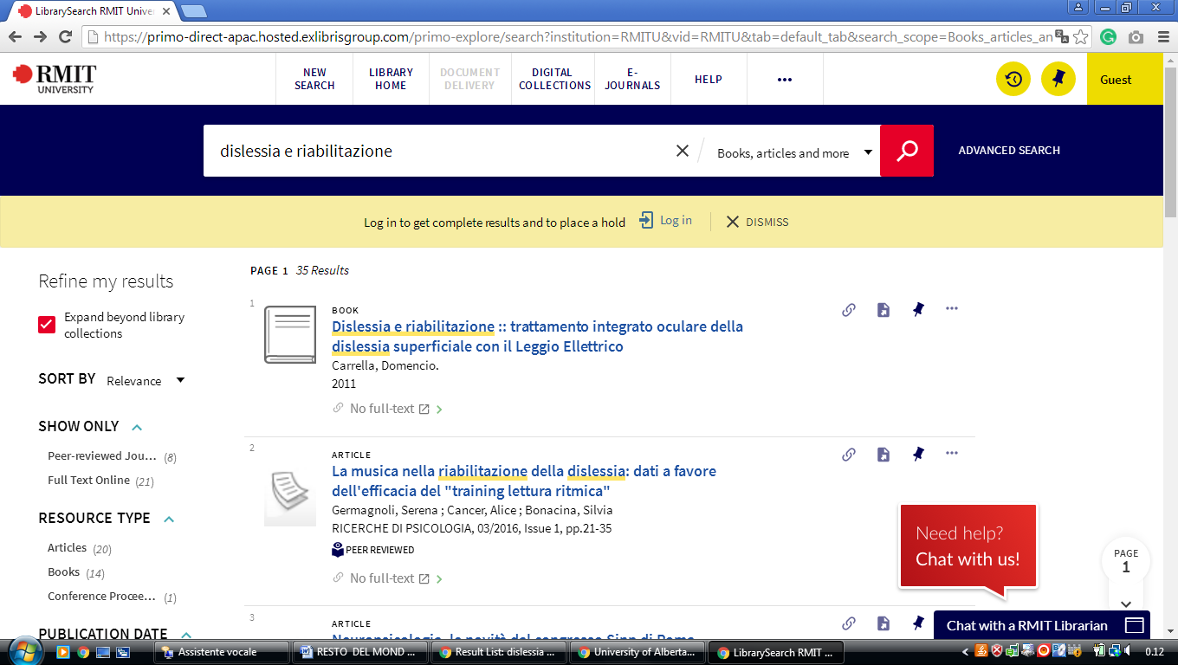

**12** [**USQ LIBRARY**](https://library.usq.edu.au/) **- (**University Of Southern Queensland Library, Australia)

[https://usq.summon.serialssolutions.com/search?s.q=dislessia+e+riabilitazione&s.fvf%5B%5D=ContentType%2CBook+Review%2Ct&s.fvf%5B%5D=ContentType%2CNewspaper+Article%2Ct#!/search?ho=f&fvf=ContentType,Book%20Review,t%7CContentType,Newspaper%20Article,t&l=it-IT&q=dislessia%20e%20riabilitazione](https://usq.summon.serialssolutions.com/search?s.q=dislessia+e+riabilitazione&s.fvf%5B%5D=ContentType%2CBook+Review%2Ct&s.fvf%5B%5D=ContentType%2CNewspaper+Article%2Ct%23!/search?ho=f&fvf=ContentType,Book%20Review,t%7CContentType,Newspaper%20Article,t&l=it-IT&q=dislessia%20e%20riabilitazione)

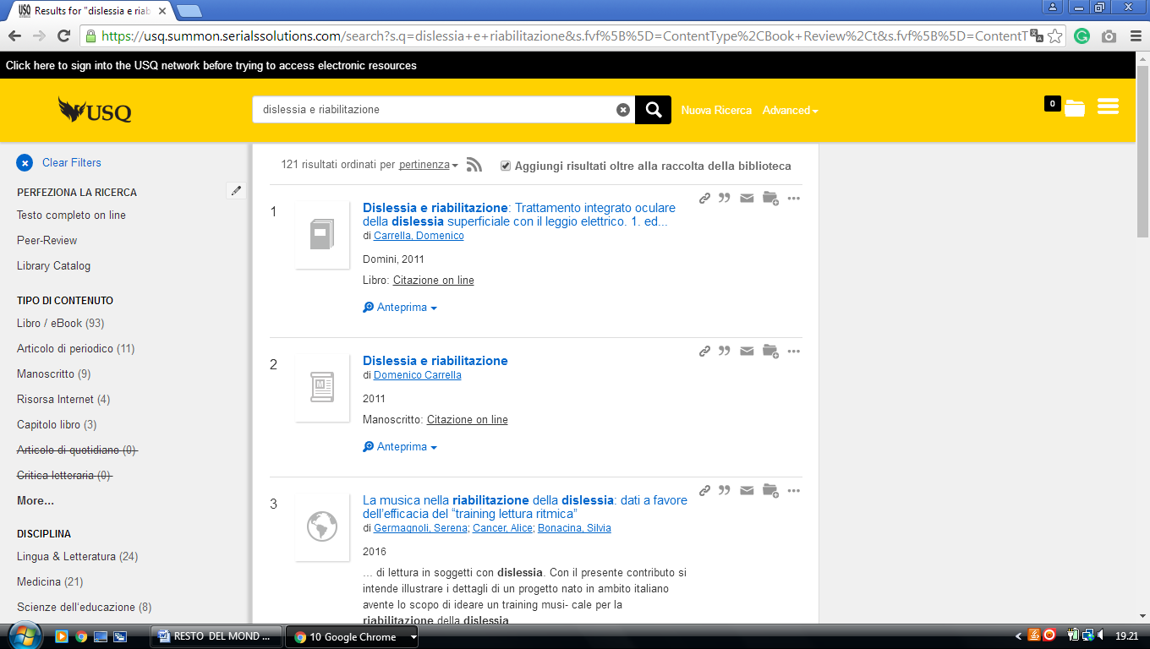

**13**  [**STATE LIBRARY OF QUEENSLAND**](http://www.slq.qld.gov.au/) **LIBRARY** –(South Brisbane, Australia)

<http://onesearch.slq.qld.gov.au/primo_library/libweb/action/search.do?ct=facet&pcAvailabiltyMode=true&pcAvailClicked=true&vl(D45500790UI0)=any&query=any%2Ccontains%2C%20dislessia%20e%20riabilitazione&fn=search&indx=1&dscnt=0&search_scope=SLQ_PCI_EBSCO&vl(1UIStartWith0)=contains&scp.scps=scope%3A(BLOGS)%2Cscope%3A(SLQEC)%2Cscope%3A(FH_COMBINED)%2Cscope%3A(SAW)%2Cscope%3A(IC)%2Cscope%3A(SLQ)%2Cscope%3A(DT)%2Cscope%3A(QS)%2Cprimo_central_multiple_fe&onCampus=false&vid=SLQ&ct=search&institution=SLQ&tab=default_tab&vl(freeText0)=%20dislessia%20e%20riabilitazione&group=Guest&dstmp=1518131939970&fromDL>

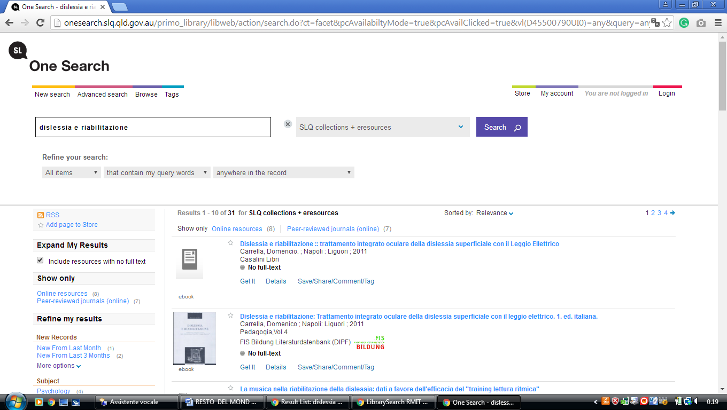

**14** [**UWA LIBRARY - THE UNIVERSITY OF WESTERN AUSTRALIA**](http://www.library.uwa.edu.au/) [(Perth](https://en.wikipedia.org/wiki/Perth), [Western Australia](https://en.wikipedia.org/wiki/Western_Australia), Australia)

[https://onesearch.library.uwa.edu.au/discovery/search?query=any,contains,dislessia%20e%20riabilitazione&tab=WorldCat&search_scope=WorldCat&vid=61UWA_INST:UWA&offset=0&pcAvailability=true](https://onesearch.library.uwa.edu.au/discovery/search?query=any,contains,dislessia%20e%20riabilitazione&tab=WorldCat&search_scope=WorldCat&vid=61UWA_INST:UWA&offset=0&pcAvailability=true%20%20%20%20)

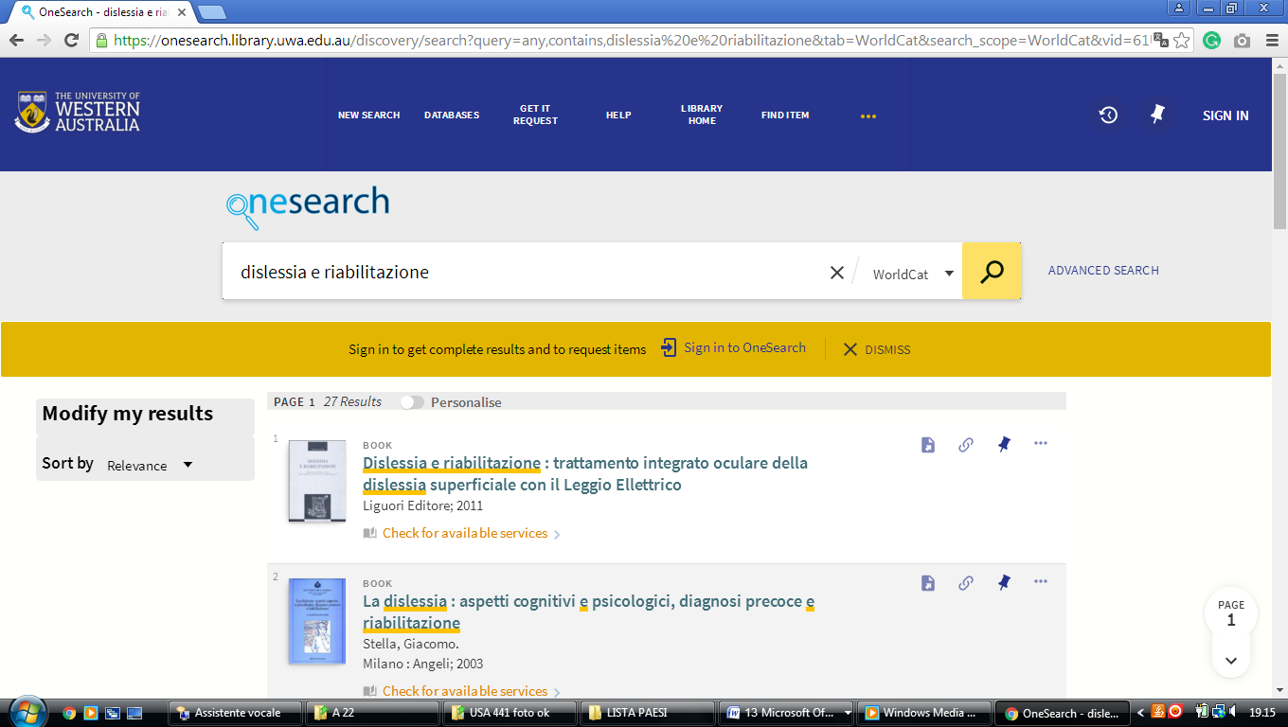

RMIT Universityl ibrary

<https://primo-direct-apac.hosted.exlibrisgroup.com/primo-explore/search?query=any,contains,dislessia%20e%20riabilitazione&tab=default_tab&search_scope=Books_articles_and_more&vid=RMITU&offset=0&pcAvailability=true>

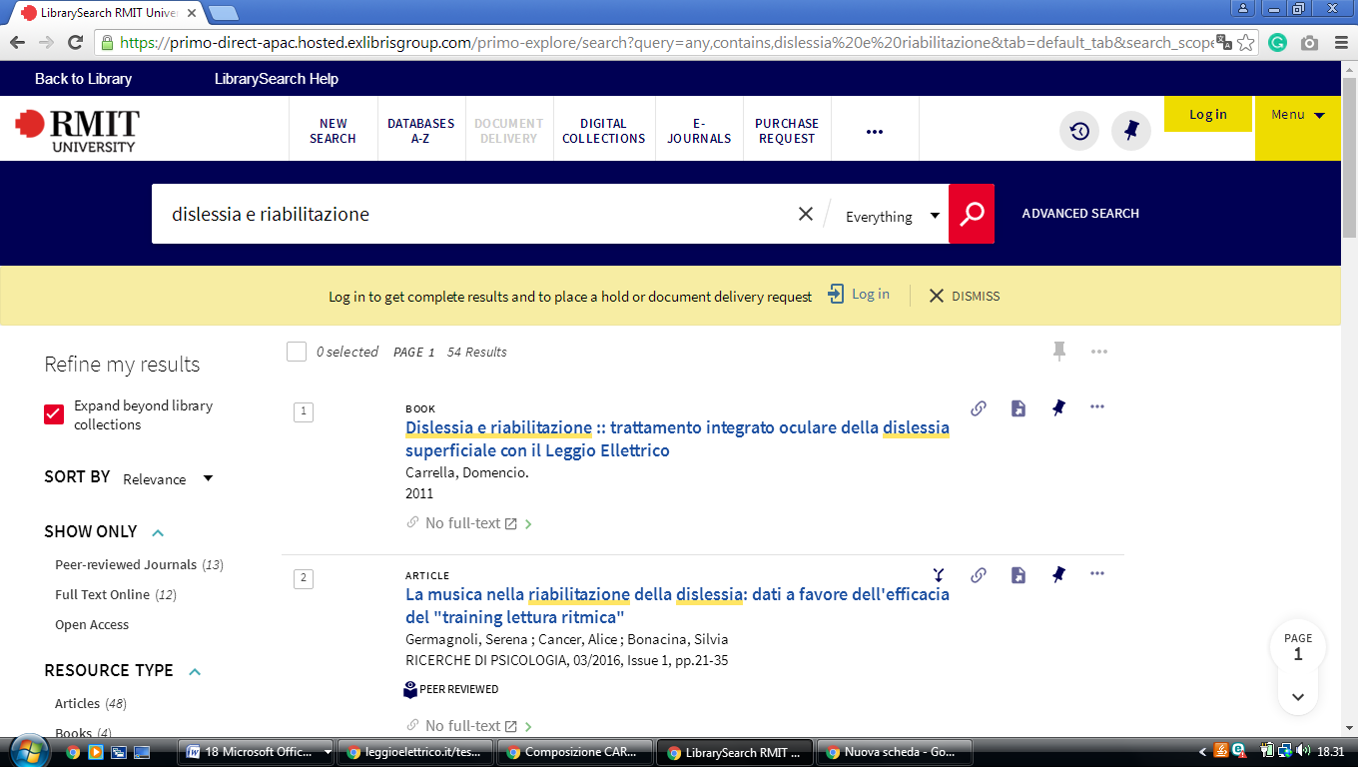

### [New Search - University of Melbourne library catalogue](http://cat.lib.unimelb.edu.au/search/)

<http://eds.a.ebscohost.com/eds/results?vid=0&sid=bacfd2b7-9c2e-4dd1-a9c8-f5259264980a%40sessionmgr4008&bquery=dislessia%2Be%2Briabilitazione&bdata=JnR5cGU9MCZzZWFyY2hNb2RlPVN0YW5kYXJkJnNpdGU9ZWRzLWxpdmU%3d>

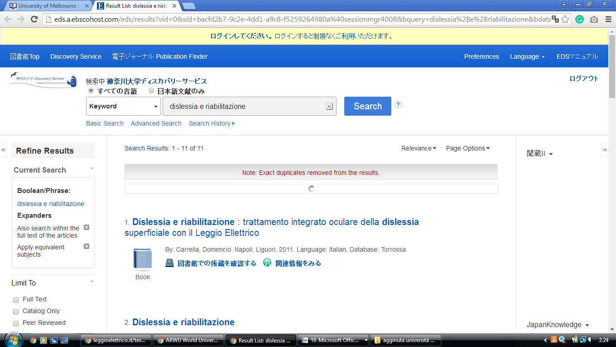

[ANU library -libraryLibrary](http://anulib.anu.edu.au/)

[**https://anu.summon.serialssolutions.com/search?q=dislessia+e+riabilitazione+trattamento+integrato+oculare+della+dislessia+su&button3=GO#!/search?ho=f&l=en&q=dislessia%20e%20riabilitazione%20trattamento%20integrato%20oculare%20della%20dislessia%20su&button3=GO**](https://anu.summon.serialssolutions.com/search?q=dislessia+e+riabilitazione+trattamento+integrato+oculare+della+dislessia+su&button3=GO%23!/search?ho=f&l=en&q=dislessia%20e%20riabilitazione%20trattamento%20integrato%20oculare%20della%20dislessia%20su&button3=GO)

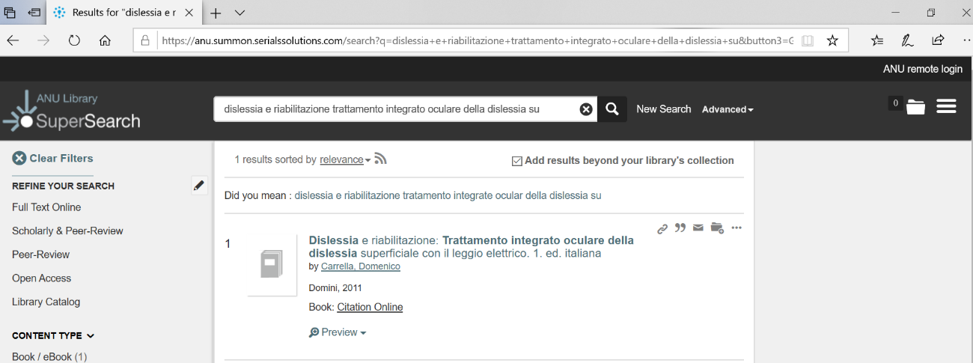

### [University of Queensland, Gatton (J.K. Murray) Library (Highly ...](https://www.alia.org.au/university-queensland-gatton-jk-murray-library-highly-commended)

https://search.library.uq.edu.au/primo-explore/search?query=any,contains,dislessia%20e%20riabilitazione&tab=61uq_all&search_scope=61UQ_All&sortby=rank&vid=61UQ&offset=0&facet=rtype,exclude,newspaper_articles&facet=rtype,exclude,reviews&pcAvailability**=true**

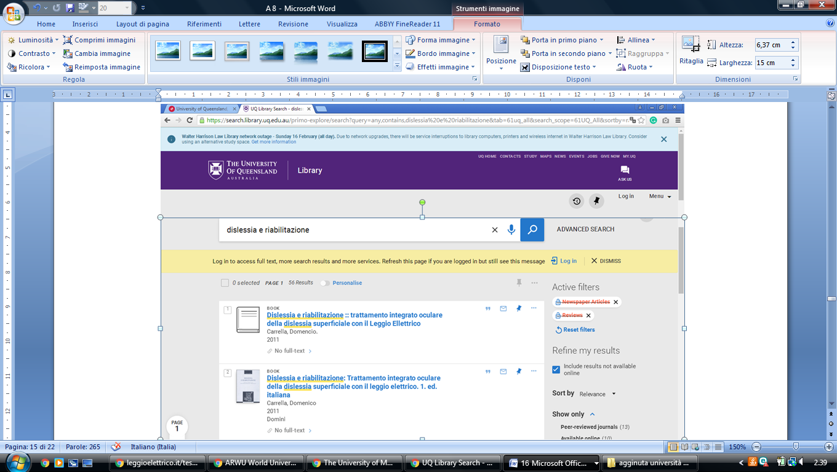

[**University Library - UWA**](https://www.uwa.edu.au/library/home)

<https://onesearch.library.uwa.edu.au/discovery/search?query=any,contains,dislessia%20e%20riabilitazione&tab=WorldCat&search_scope=WorldCat&sortby=rank&vid=61UWA_INST:UWA&offset=0&search_text=dislessia%20e%20riabilitazione>

